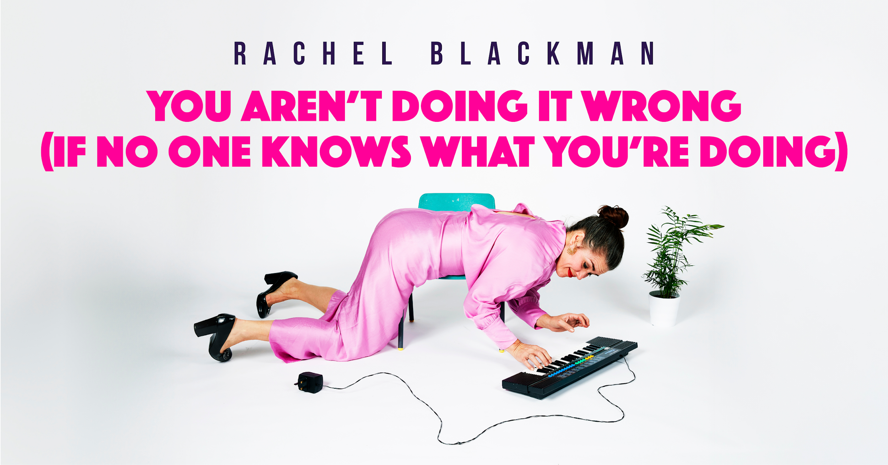

This visual story is to help you prepare for your visit to see
You Aren’t Doing It Wrong (If No One Knows What You Are Doing)
Brighton Dome Studio Theatre
Wednesday 16 and Thursday 17 July 2025
Both shows will be relaxed performances and there will be BSL interpretation on Thursday 17 July.
During both relaxed performances you can make noise or move around in the auditorium, you don’t have to worry that someone will tell you to stop. You can leave the auditorium at any time, and you can come and go as much as you like.
The show will last about 80 minutes and there will be no interval.

Arriving at Brighton Dome

You will be arriving to Entrance 1 on New Road. This is what Entrance 1 looks like:
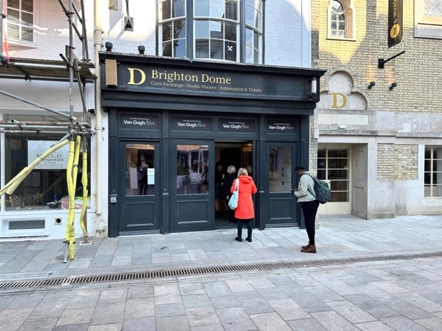

When you arrive, a member of staff will scan your tickets, and if you have any bags, these may be checked by a member of our security team.

Our Staff wear black shirts with a gold Brighton Dome logo, like this:


You will be able to wait in our Gallery and Festival Bars before the performance. They look like this:

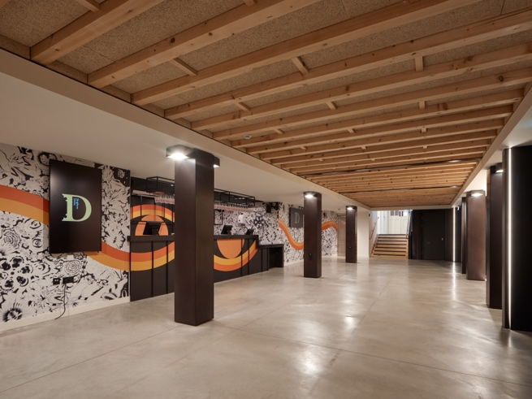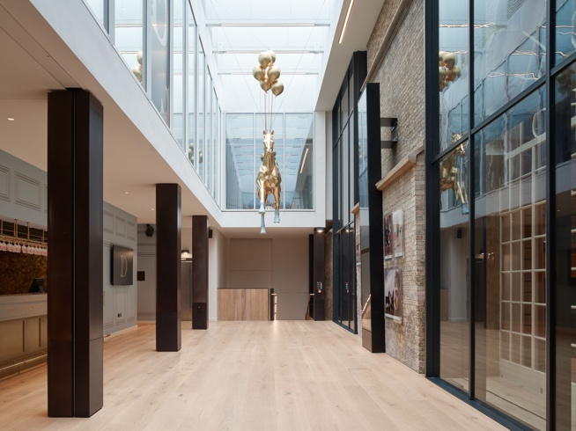

Toilets, including accessible toilets, are located to the right-hand side of both bars. If you are unsure, a member of staff will be able to help you locate them.

These are the toilets in the Festival Bar:

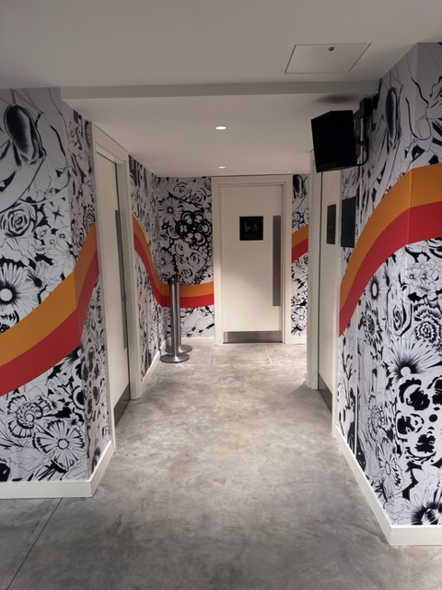

You Aren’t Doing It Wrong (If No One Knows What You’re Doing)

There will be one performer on stage, her name is Rachel Blackman. Here is a photo of Rachel:



This is a picture of the set on the stage which is similar to someone’s living room:

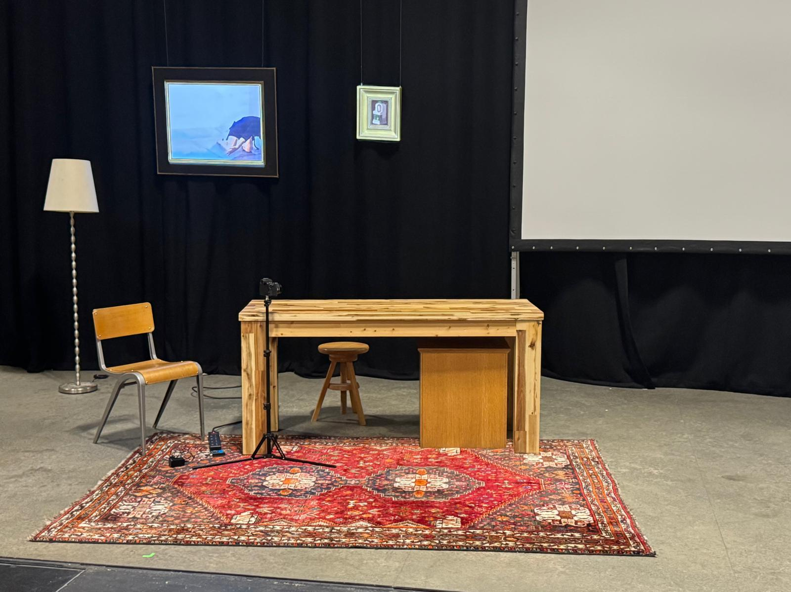

The show is an interactive solo performance about failure, feeling like an idiot and music…
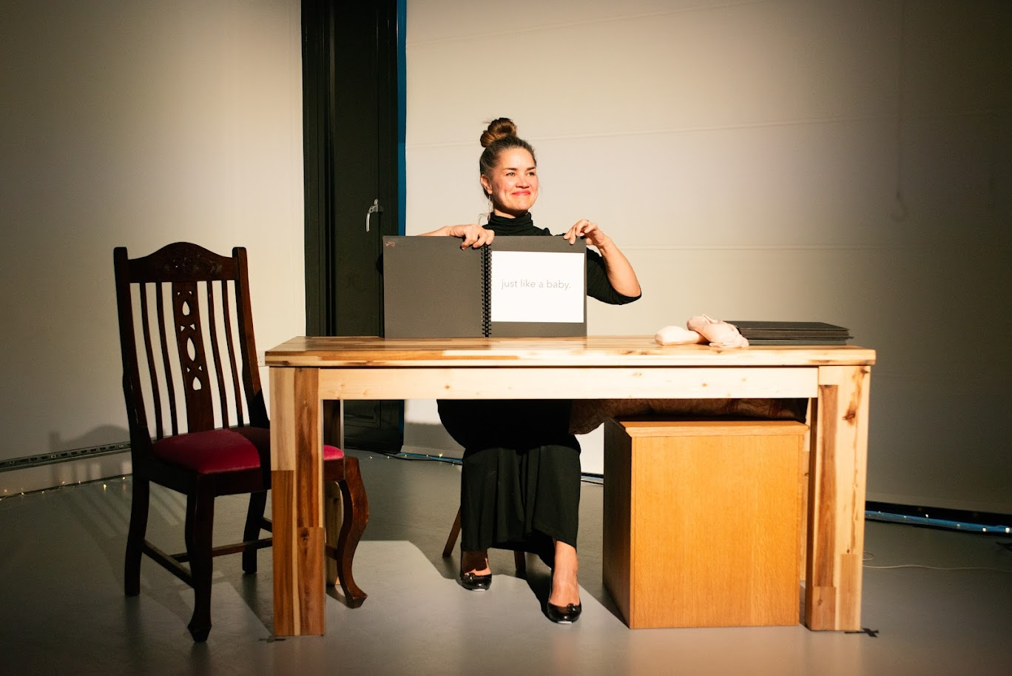
The narrative is in three acts. We meet Rachel on stage and the narrative unfolds around her experiences growing up in and around music, the impacts this had on the relationships with her family and throughout her life. The story delves into perfectionism, imposter syndrome and our right to fail.

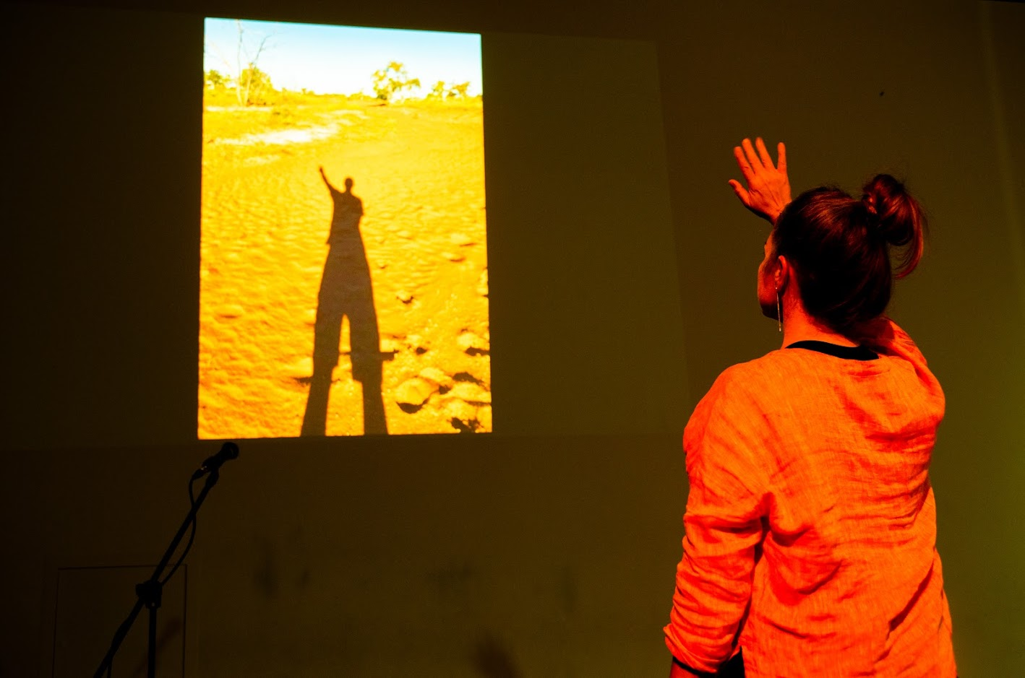

It’s told through a combination of confessional story books, direct conversation to the audience, a cut scene with a special guest and some dancing! All the scenes are accompanied with lots of music, some projection and a number of props! (some of which will be familiar!)

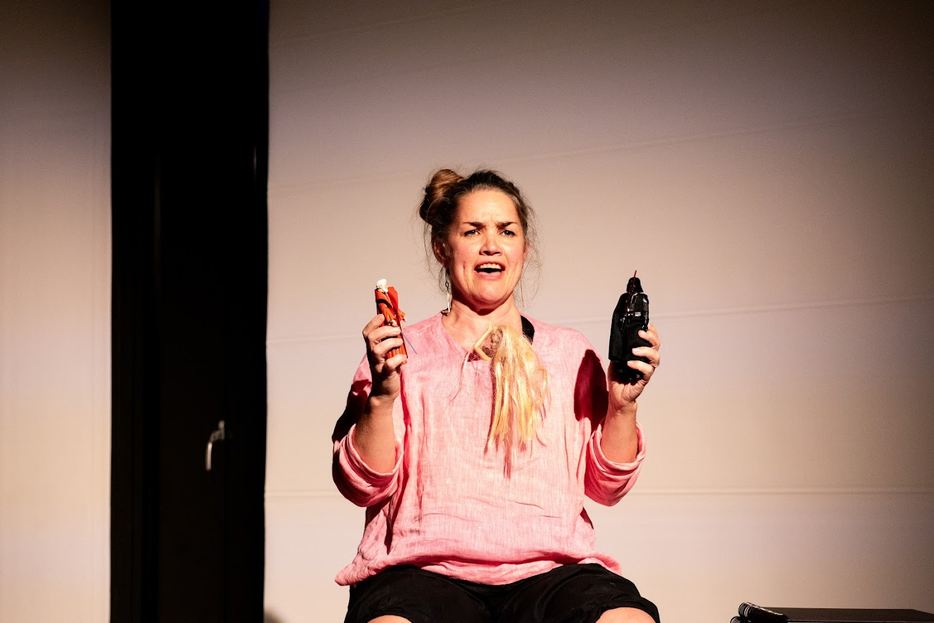

The soundtrack to the performance is varied in style, some is loud and fast paced at times and discordant, other times slow and melodic. The set has elements that light up or are projected on and a picture is lowered onto the stage area during the performance.

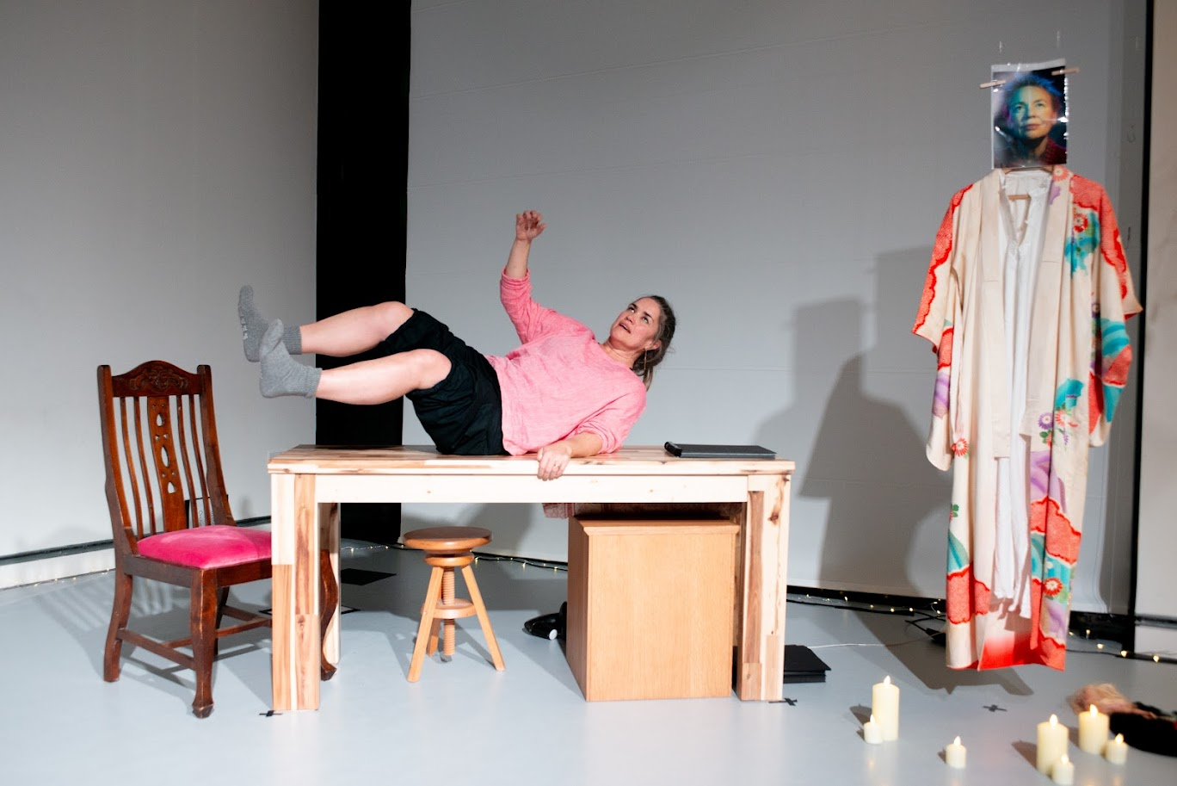

There is no audience interaction in the show as such, rather some direct conversations to the audience as a whole.

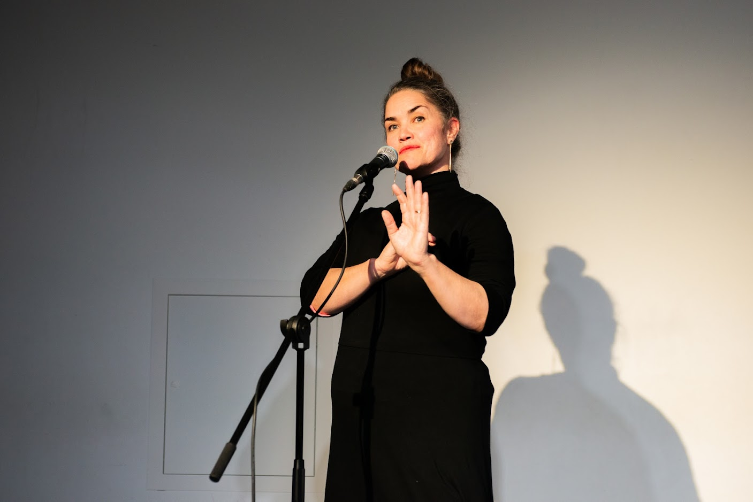

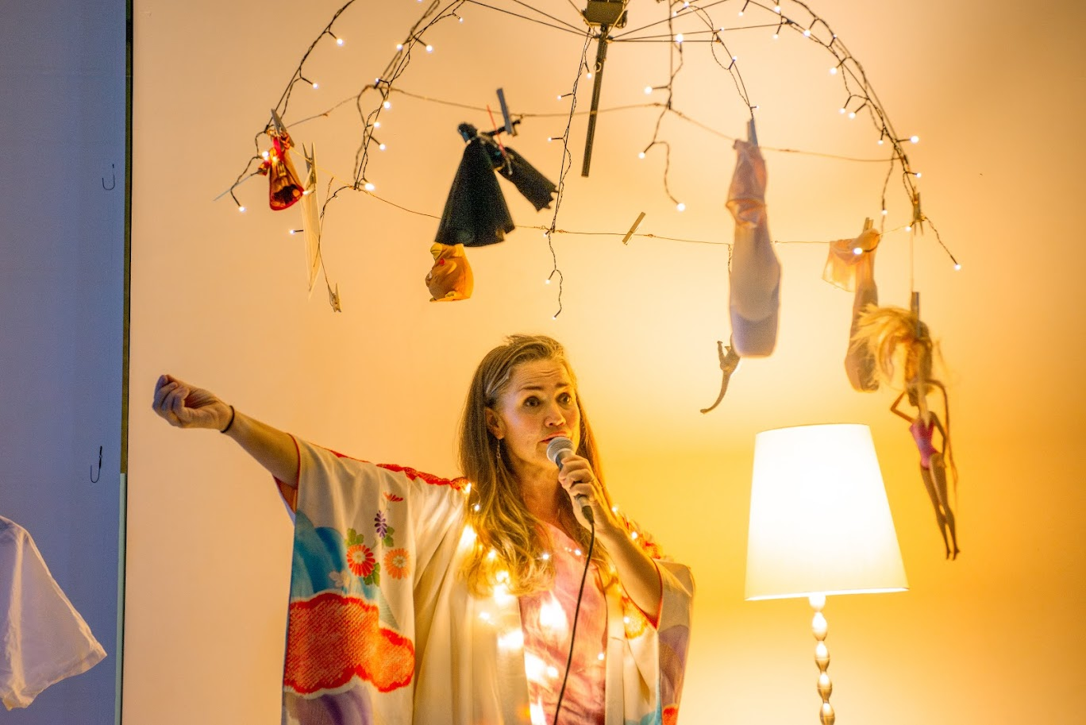

You can watch of trailer of our show HERE

We hope you enjoy the show!
Here’s our website for more info. Tiny Failures

