
Website: brightondome.org
Twitter: @brightdome
Instagram: @brighton_dome
Facebook: brightondome

MONDAY 19 JANUARY 2026 – FOR IMMEDIATE RELEASE

Family events at Brighton Dome this Spring

- Little Angel Theatre bring We’re Going on a Bear Hunt to life through music and puppetry
- Brand-new Horrible Histories – The Concert, featuring songs and characters from the hit CBBC TV show
- Rude Science Live returns with more sensational stunts and explosive experiments
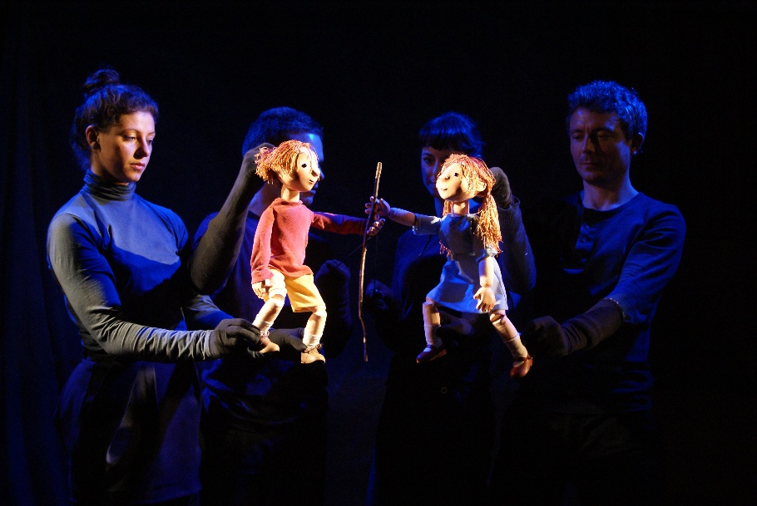
Brighton Dome welcomes a range of engaging and entertaining events for children of all ages and their families to its three venues this this spring.
For the February half term holiday, leading children’s theatre Little Angel Theatre bring their live stage adaptation of Michael Rosen’s We’re Going on a Bear Hunt to the Corn Exchange (20–22 Feb). Combining puppetry, music and song, this enchanting show brings this thrilling and funny adventure to life for ages 3–8. On 19 Feb, outrageously funny and fascinating Rude Science Live returns to Brighton Dome. Presented by award-winning CBBC presenter Stefan Gates, this high-energy show is packed with naughty and fun science experiments that will delight ages 5 and up. And on 15 Feb, The Next Step: Legacy World Tour, a brand-new live dance show comes to Brighton Dome. Based on the hit CBBC show, The Next Step will star fan-favourite cast members, performing showstopping choreography ideal for young dance enthusiasts.
This Easter, Horrible Histories – The Concert comes to Brighton Dome Concert Hall (9–11 Apr). Featuring a live band and songs, characters and TV actors from the BAFTA Award-winning CBBC series, the brand-new production will follow the story of William Shakespeare attempting to create the greatest show on earth, told through Horrible Histories’ trademark blend of music and comedy (ages 5+).
On 15 Mar, Half Moon Theatre performs Last Unicorn Airways in the Studio Theatre, suitable for ages 4–9 and children of all ages with complex needs and disabilities. Adapted from a Hans Christian Anderson story, the show follows the adventure of two whimsical baggage handlers on a fantastical journey around the world. After the show, audiences can step into a sensory immersive installation, offering a unique, interactive experience. Families can also take part in Crafty Kids workshops (8 Feb and 15 Mar), for relaxed and fun art sessions with all materials provided (ages 3+). Later in the year, children’s author Michael Rosen presents Nice! Stories and Rhymes with Michael Rosen (11 Jun). In celebration of his 80th birthday, Michael will perform some of his classic poems, alongside new work, in a delightful one-man show for all ages.
For more details visit brightondome.org

ENDS

Notes to Editors

For more information or to arrange interviews, previews and reviews, please contact:

Alex Jacobs, Communications Officer – alex.jacobs@brightondome.org
Katie Fowler, Acting Head of Communications – katie.fowler@brightondome.org

Dropbox image link: https://tinyurl.com/4ksmf9mf

About Brighton Dome & Brighton Festival
Brighton Dome & Brighton Festival is a creative charity that produces a year-round programme of music, comedy, theatre, dance, literature, conferences and events across three venues - the Concert Hall, Corn Exchange and Studio Theatre. We produce Brighton Festival, England’s largest multi-arts international Festival, over three weeks every May and are the home for Create Music, which provides music tuition and opportunities to over 30,000 children in over 500 schools across the whole of Sussex.

Located on the Royal Pavilion Estate, Brighton Dome’s venues have a rich history spanning over 200 years, providing extraordinary spaces for artists and audiences. A major capital refurbishment project to restore and protect the Grade I and Grade II listed Corn Exchange and Studio Theatre was completed in 2023, equipping these spaces for a sustainable future.

brightondome.org / brightonfestival.org / createmusic.org.uk
Twitter: @brightdome, @brightfest, @createmusicUK, @FCreatorsUK
Instagram: @brighton_dome, @brightonfestival, @createmusicuk, @futurecreatorsuk
Facebook: brightondome, Brighton Festival, createmusic, futurecreatorsuk

