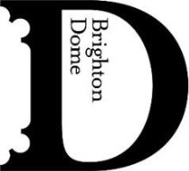
4 FEBRUARY 2026 – FOR IMMEDIATE RELEASE
Music hall mashups and powerful performance poetry at Brighton Dome this spring
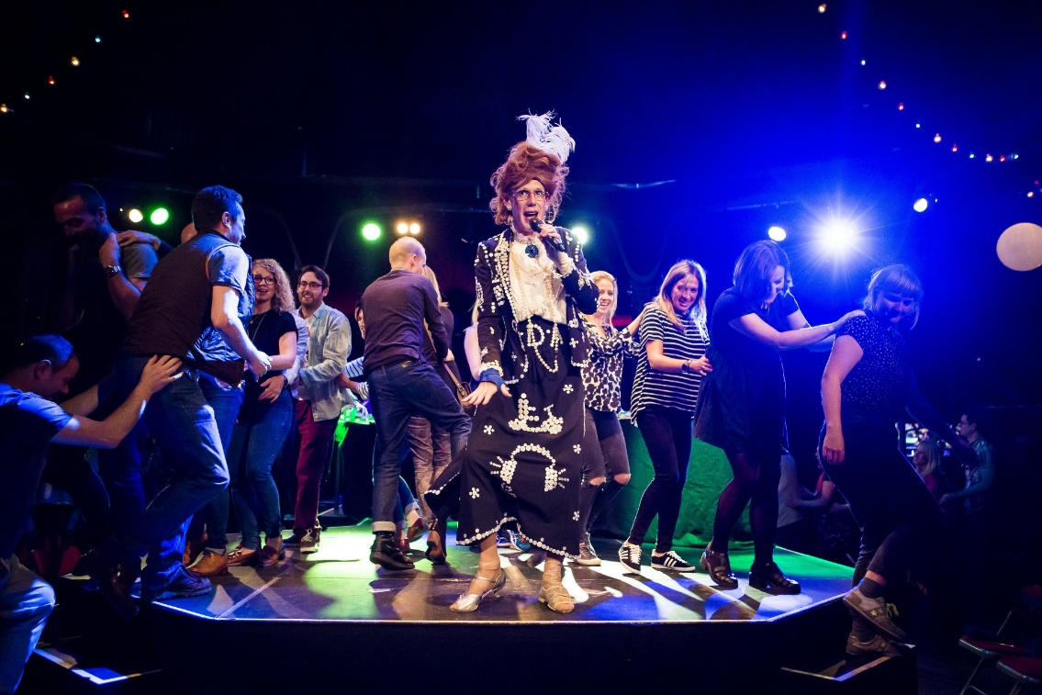

This spring, Brighton Dome welcomes four theatre productions to intrigue, entertain and inspire. From tongue-in-cheek drag to thought-provoking one man shows, the Studio Theatre blooms with shows for all audiences.

From 12–14 February, House of Life transforms the Studio Theatre into a haven of connection and community. Part rave, part theatre, the genre-defying, immersive show is a feel-good evening of music, movement and communal healing. Hosted by the glitter-clad RaveRend, House of Life invites audiences to let go and rediscover the joy of collective celebration.

Later in February, Made You Look (25–26 February) by Ty’rone Haughton, the Trainee Artistic Director of spoken word trailblazers Apples and Snakes, the show fuses poetry, physical theatre and visual art. In a powerful one-man performance, Haughton interrogates masculinity and what it means to be an immigrant in modern Britain. The set also doubles as an exhibition, which audiences are encouraged to explore after the performance. Each night opens with poetry from Gray Taylor, a Brighton-based poet whose work blends conversational storytelling with hip hop, grime and R&B influences.

Renowned drag artist, singer and local legend Ida Barr (Ida Barr Show, Barbican; Ida Barr’s Jubilee, National Theatre) returns to Brighton Dome with Slipped Disco (5–6 March). A retired music hall star turned hip hop artist, Ida Barr galvanises her audience with singalongs, comedy and fresh beats. Quirky and light-hearted, Slipped Disco is a show celebrating the complexity and absurdity of life, in the company of the UK’s premier OAP rapper.

The theatre spring season at Brighton Dome concludes with Please Do Not Touch (7 March). When an activist who explores historic houses on TikTok is wrongly imprisoned, he must find a way out in the face of systems trying to silence him. Written by former Birmingham Poet Laureate Casey Bailey (GrimeBoy, Birmingham Rep) and directed by award-winning theatre maker, Gail Babb (Stars, Tamasha – OFFIE’S Best New Play 2024), Please Do Not Touch stars Selorm Adonu (G, Royal Court Theatre; Brother’s Keeper, Theatre Peckham) in a thought-provoking show about colonial legacy and contested heritage.

For more details visit brightondome.org

ENDS

House of Life
12–14 February
Studio Theatre, Brighton Dome

Made You Look
25–26 February
Studio Theatre, Brighton Dome

Ida Barr: Slipped Disco
5–6 March
Studio Theatre, Brighton Dome

Please Do Not Touch
7 March
Studio Theatre, Brighton Dome

Notes to Editors

For more information, or to arrange interviews, previews and reviews, please contact:

Katie Fowler, Acting Communications Manager – katie.fowler@brightondome.org
Alex Jacobs, Communications Officer – alex.jacobs@brightondome.org

Images: https://tinyurl.com/BDtheatrespring2026

About Brighton Dome & Brighton Festival
Brighton Dome & Brighton Festival is a creative charity that produces a year-round programme of music, comedy, theatre, dance, literature, conferences and events across three venues - the Concert Hall, Corn Exchange and Studio Theatre. We produce Brighton Festival, England’s largest multi-arts international Festival, over three weeks every May and are the home for Create Music, which provides music tuition and opportunities to over 30,000 children in over 500 schools across the whole of Sussex.

Located on the Royal Pavilion Estate, Brighton Dome’s venues have a rich history spanning over 200 years, providing extraordinary spaces for artists and audiences. A major capital refurbishment project to restore and protect the Grade I and Grade II listed Corn Exchange and Studio Theatre was completed in 2023, equipping these spaces for a sustainable future.

brightondome.org / brightonfestival.org / createmusic.org.uk
Twitter: @brightdome, @brightfest, @createmusicUK, @FCreatorsUK
Instagram: @brighton_dome, @brightonfestival, @createmusicuk, @futurecreatorsuk
Facebook: brightondome, Brighton Festival, createmusic, futurecreatorsuk

