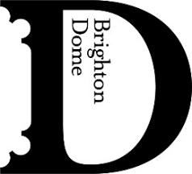
TUESDAY 14 APRIL – FOR IMMEDIATE RELEASE

Breakin’ Convention back at Brighton Dome
Wednesday 27 May 2.30pm and 7.30pm

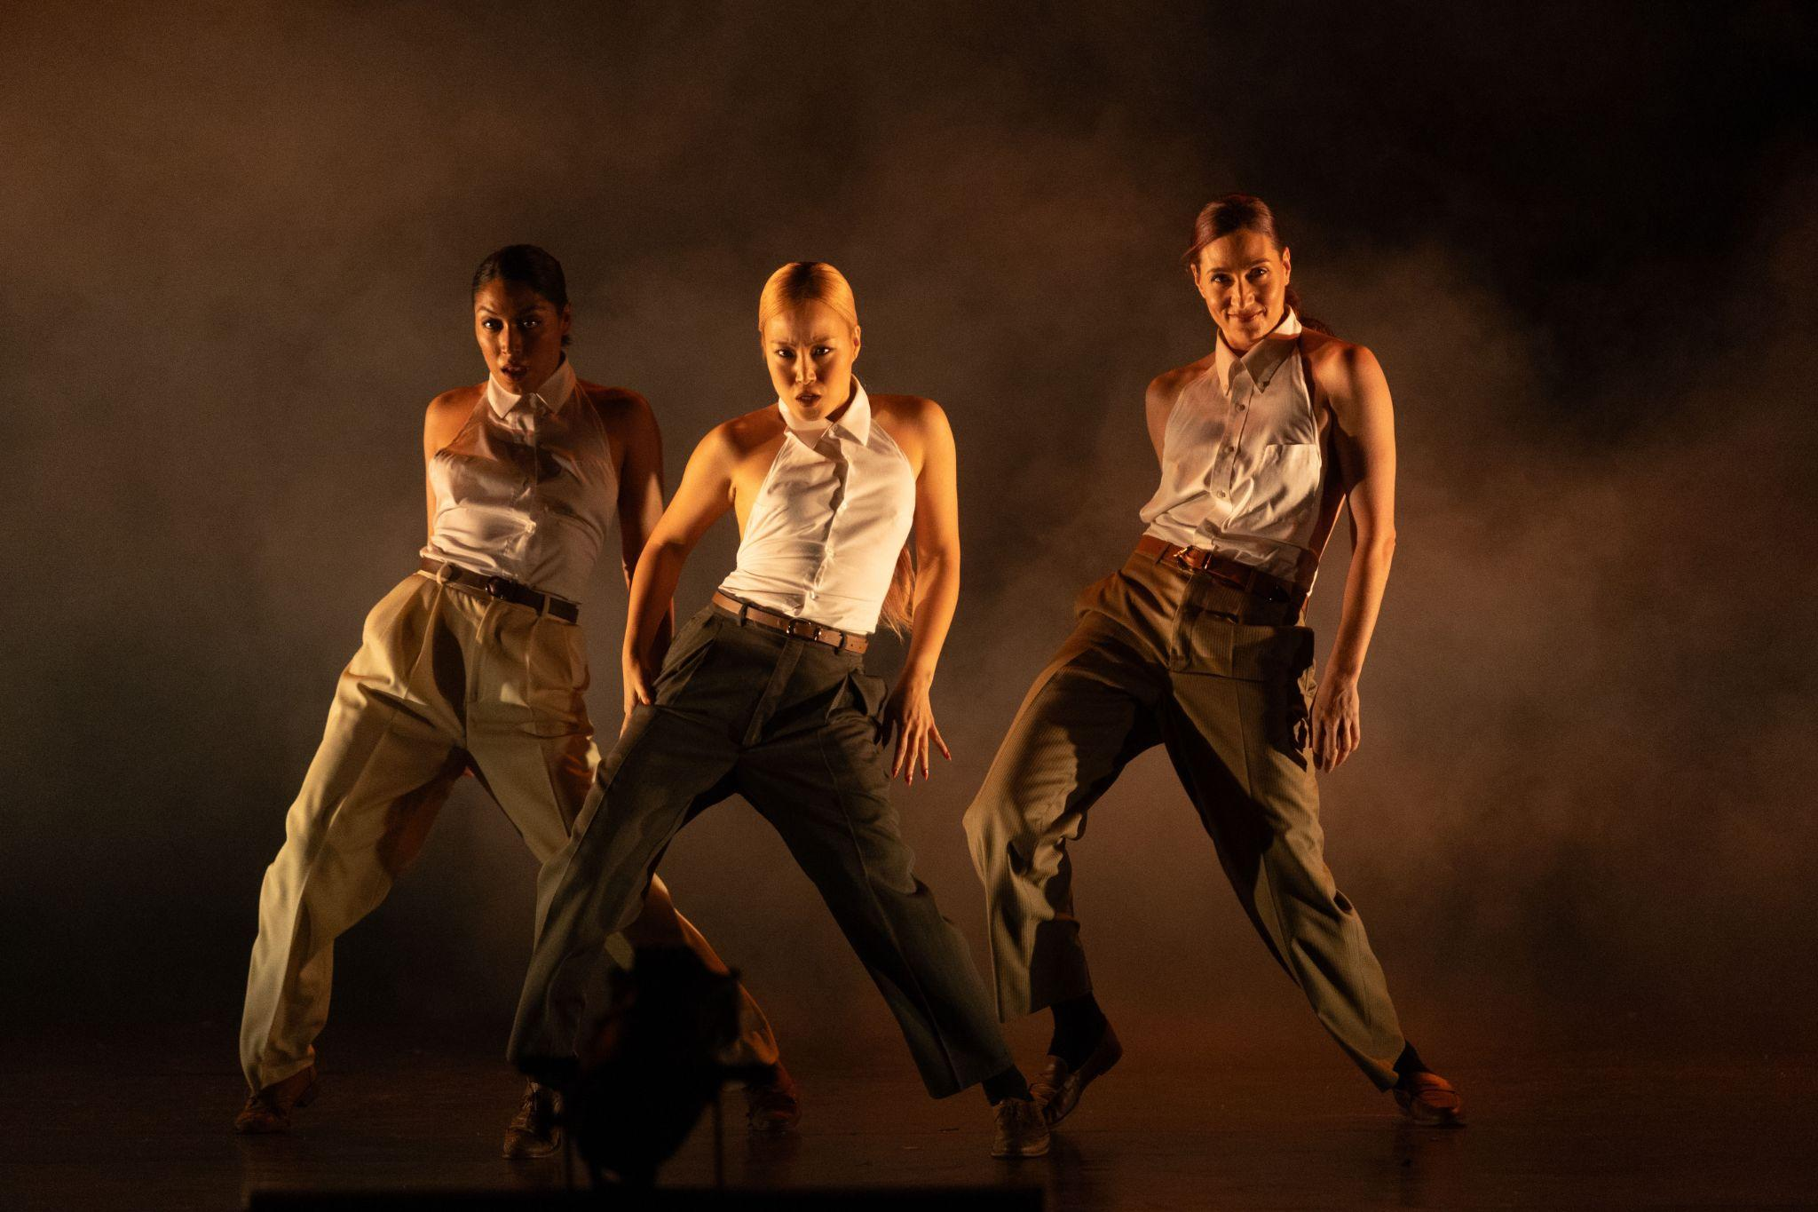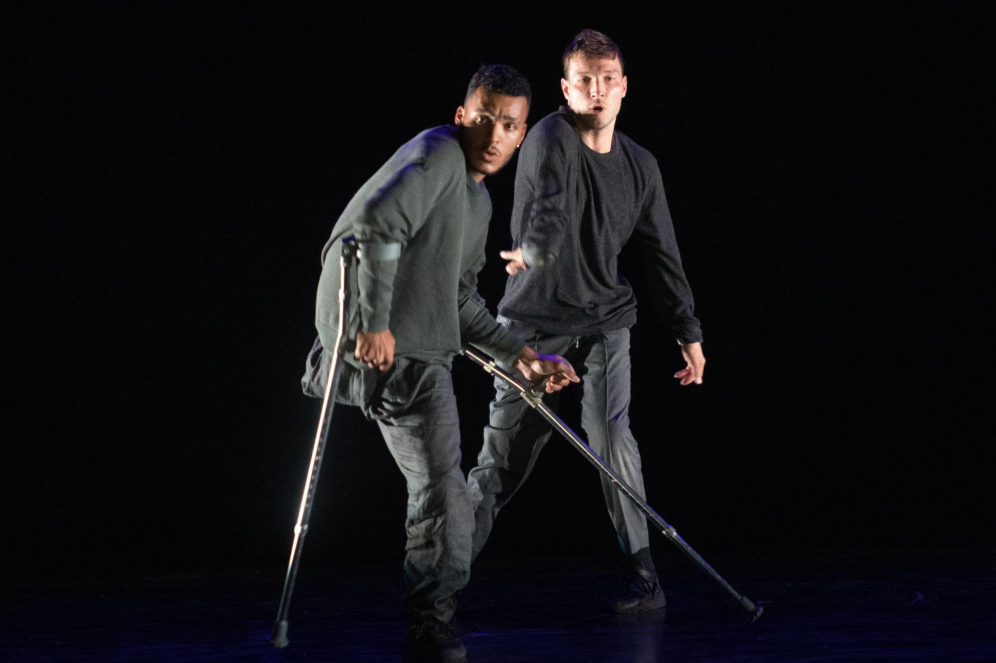

Breakin’ Convention, the groundbreaking festival of hip hop dance theatre, returns to Brighton Dome on Wednesday 27 May.

With a prestigious national and international lineup of dancers selected by Breakin’ Convention Artistic Director, Sadler’s Wells Associate Artist and event MC Jonzi D , DJs, graffiti artists and freestyle sessions alongside will total a complete Breakin’ Convention takeover of the venue.

The Brighton shows will also feature performances from three local dance crews. Led by Breakin’ Convention’s Brighton representative JP Omari, multi-award-winning street dance school Streetfunk showcases different dance styles in a piece inspired by the structure and harmony of an orchestra. Brighton-based Project Female’s young dancers bring their fusion of contemporary and hip hop styles to the stage, while the city’s Visual Poets Company present dance theatre centred around physical storytelling, atmosphere and collective experience.

The national and international line up for Breakin’ Convention’s 2026 tour features the powerful Olivier Award-winning TRAPLORD, created by prolific artist and choreographer Ivan Blackstock whose innovative body of work includes collaborations with artists such as Beyoncé as well as solo performances, film and more. Exploring masculinity and mental health, TRAPLORD is an explosive fusion of movement and storytelling challenging racial stereotypes of Black men.

The 2026 tour lineup also includes Los Angeles-based trio Femme Fatale who are of French, Mexican and Korean origin. Renowned for their slick and timeless performances, stylish musicality and razor-sharp moves, Femme Fatale’s appearances at Breakin’ Convention in recent years have been acclaimed by audiences and critics alike.

Trailblazing collective ILL-Abilities, an all-star crew of differently abled b-boys hailing from the Netherlands and Brazil also tour the UK, are returning to Breakin’ Convention and Brighton by popular demand, having previously performed in 2023. Refusing to accept any perceived limitations, their remarkable skills have generated headlines and packed-out venues since their early days.

Jonzi D, Artistic Director of Breakin’ Convention, said “Our latest UK tour features new venues, award winning conceptual work, an international popping trio and the most unique breakers in the world. We never stop breakin’ convention!”

Since 2004, Breakin’ Convention, based at Sadler’s Wells Theatre in London and helmed by Jonzi D and Michelle Norton, has led the global hip hop dance theatre movement, showcasing leading artists and connecting communities through the power of dance, music, and storytelling. In addition to the annual Festival at Sadler’s Wells, Breakin’ Convention runs highly successful artist development
programmes including Open Art Surgery and Back To The Lab. Breakin’ Convention has toured acts up and down the country, and internationally including to The Netherlands and the United States.

Earlier this year, Academy Breakin’ Convention, which provides the UK’s first Level 3 Qualification specific to hip hop theatre officially opened at Sadler’s Wells East in Stratford. The two-year course teaches students aged 16-19 seven different elements of hip hop dance theatre including Popping, Breaking, Emceeing, Social Dance, DJing, Music Production and Graffiti.

Performances: Wednesday 27 May at 2.30pm and 7.30pm

For more details and to book visit brightondome.org

ENDS

Notes to Editors

For more information about Breakin’ Convention at Brighton Dome or to arrange interviews, previews and reviews, please contact:

Katie Fowler, Communications Manager – katie.fowler@brightondome.org

For more information about Breakin’ Convention on tour and interview requests and images, please contact:

Anna Goodman: abstrakt@abstraktpublicity.co.uk

Images available here: https://www.dropbox.com/scl/fo/mz6tfy1a3l26mfby56d7k/AHLr0IiNZSIdS9_0tPrI764?rlkey=oshm9n05dds3rzdh0f0gc5qeg&st=5jeucz7w&dl=0

About Brighton Dome & Brighton Festival
Brighton Dome & Brighton Festival is a creative charity that produces a year-round programme of music, comedy, theatre, dance, literature, conferences and events across three venues - the Concert Hall, Corn Exchange and Studio Theatre. We produce Brighton Festival, England’s largest multi-arts international Festival, over three weeks every May and are the home for Create Music, which provides music tuition and opportunities to over 30,000 children in over 500 schools across the whole of Sussex.

Located on the Royal Pavilion Estate, Brighton Dome’s venues have a rich history spanning over 200 years, providing extraordinary spaces for artists and audiences. A major capital refurbishment project to restore and protect the Grade I and Grade II listed Corn Exchange and Studio Theatre was completed in 2023, equipping these spaces for a sustainable future.

brightondome.org / brightonfestival.org / createmusic.org.uk
Twitter: @brightdome, @brightfest, @createmusicUK, @FCreatorsUK
Instagram: @brighton_dome, @brightonfestival, @createmusicuk, @futurecreatorsuk
Facebook: brightondome, Brighton Festival, createmusic, futurecreatorsuk

