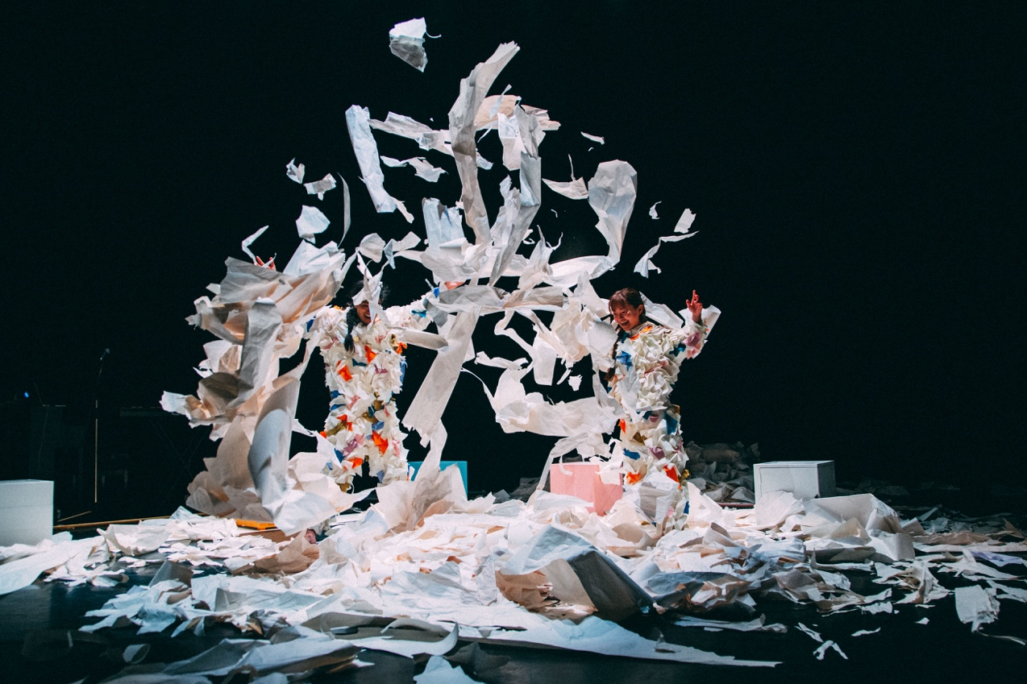


Easy Read

Club Origami

Created by

Makiko Aoyama, Robert Howat and Takeshi Matsumoto

About the performance
Performance   | Club Origami is a dance performance using lots of papers  Origami is a Japanese art of folding paper.  Instead of spoken words, there are movement and dancing to tell a story.
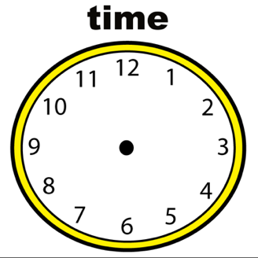 | Club Origami is 40 minutes long
Music   | There is a music played live by Rob.  The musical instrument is called Xylosynth.  Papers also create sounds.

About the performers
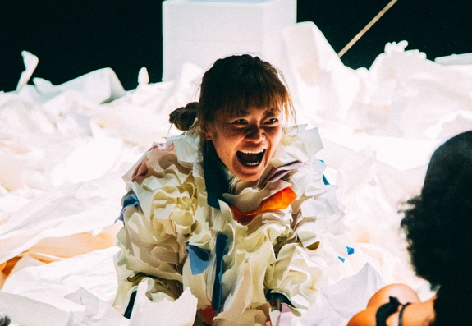 | My name is Makiko  I am the female performer in the show  - I will dance and move in the show  - I will sometimes come to you to play with paper
 | My name is Takeshi  I am the male performer in the show  - I will dance and move in the show  - I will sometimes come to you to play with paper
Music   | My name is Rob  I am the male musician in the show  - I will play Xylosynth in the show  - I will create sounds using papers

Before the performance starts
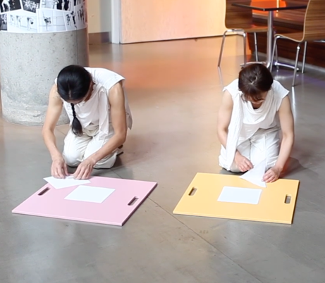 | - Before you enter the performance space, Makiko and Takeshi come out with origami paper and begin to make origami works in the foyer area
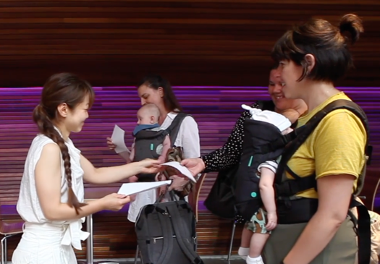 | - Makiko and Takeshi give you a sheet of origami paper to create whatever you want to create. You can copy what they made or create something new. There is no right or wrong!
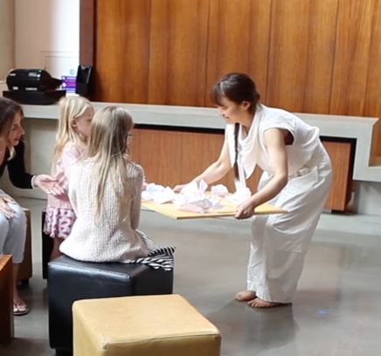 | - After you made origami work, Makiko and Takeshi collect your work, which will be used in the performance later.  - Then follow them to enter the performance space.

Club Origami scene by scene breakdown
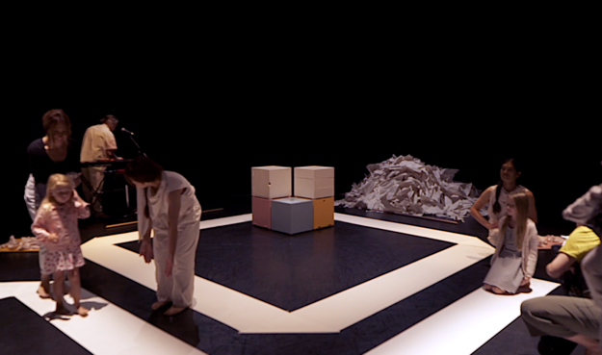 | - When you enter the space, there is a rolled out paper where you can sit on. Makiko and Takeshi are there to help you settle.  - Rob is creating a sound with ripping and scrunching papers.
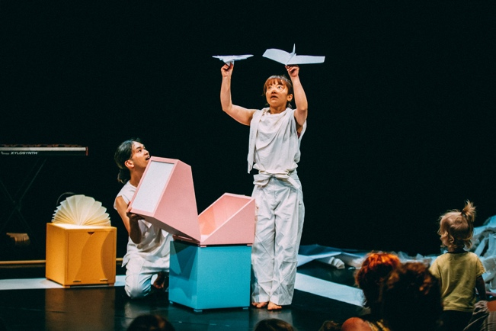 | - When everyone sits down, the performance starts.  - Makiko and Takeshi start to open each box from which origami paper works come out, like butterflies, penguins and airplanes.
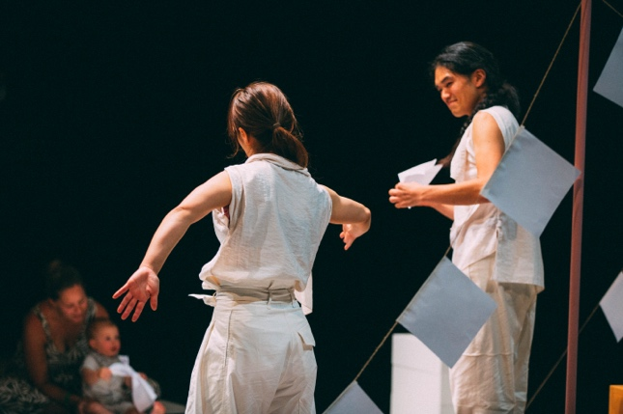 | - Makiko and Takeshi brings and places your origami work on the stage.  - Then they dance, inspired by your works! This dance is very special because your origami work is making them dance.
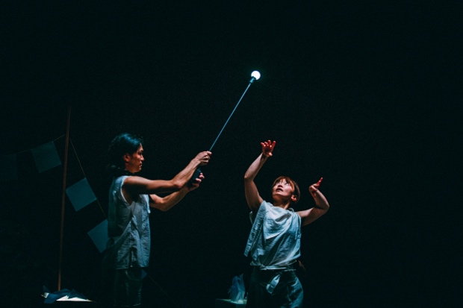 | - Takeshi brings a flying light in the space.  - The lights travels around the space visiting you and your origami work.
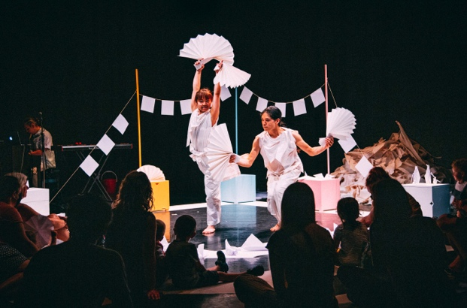 | - Paper fans appear from one of the boxes and dancers show you a fan dance with Rob’s rhythmic music. The dance is jumpy, bouncy and fun!
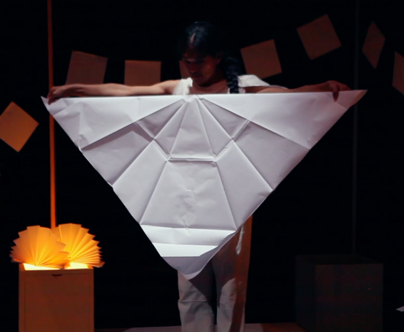 | - Takeshi brings a big sheet of origami paper and starts to create something.  - Sometimes it looks like a bird, sometimes like a jacket.
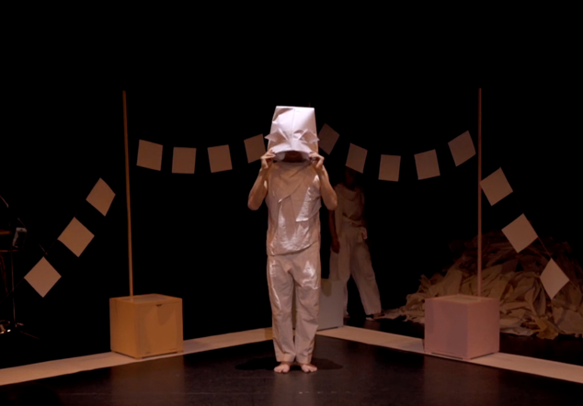 | - Takeshi makes a big hat. When he wears it over his head, something magical happens.
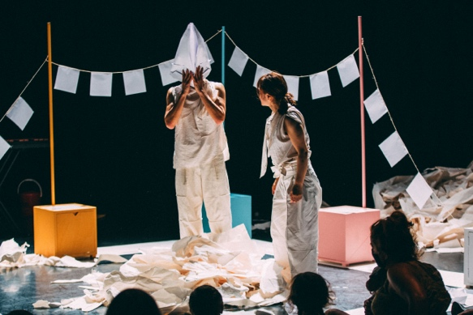 | - Makiko brings a pile of ripped papers and splashes onto the floor.  - Takeshi joins and they both fills the space with lots of ripped papers.
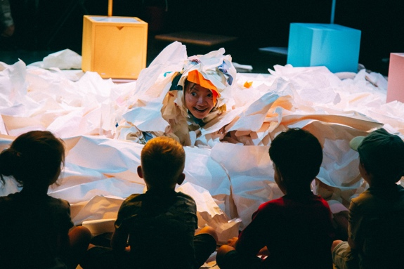 | - Makiko changes her costume and bravely jumps into the pile.  - She swims, plays with paper and comes towards you.
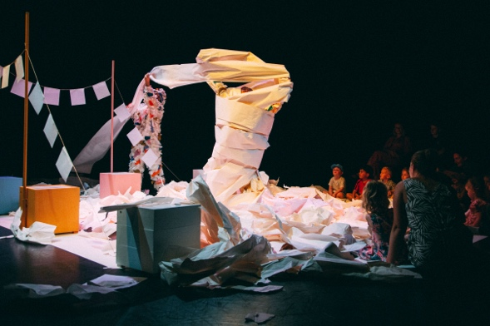 | - Makiko and Takeshi wrap a long paper around their bodies and turn into a giant.
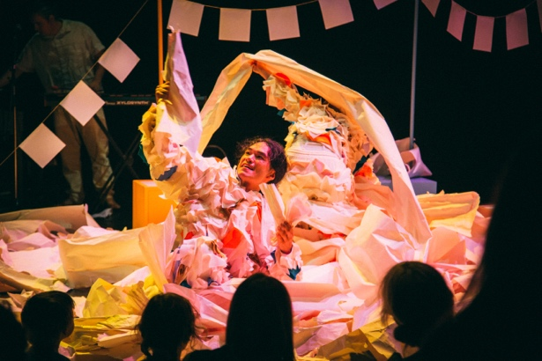 | - Makiko and Takeshi start to rip more papers and invite you into the space to play.  - You can join their play or stay where you are and rip the paper.
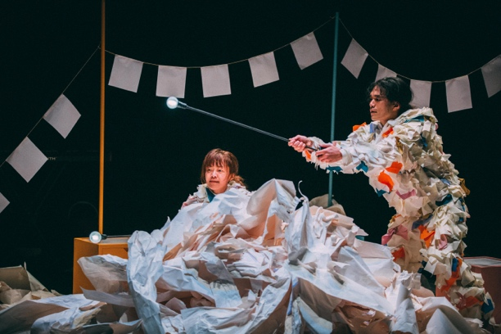 | - After we play together, the travelling light appears again to let us know that this is the end of the performance.  - The space goes dark and the light disappears.
After the performance

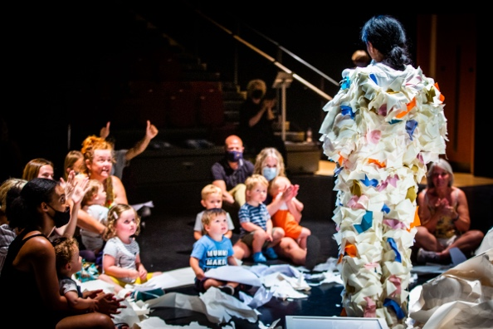 | - When the performance finishes the light comes back and the audience clap their hands.  - You can clap your hands too, if you would like to  - If the clapping is too loud, you can cover your ears.
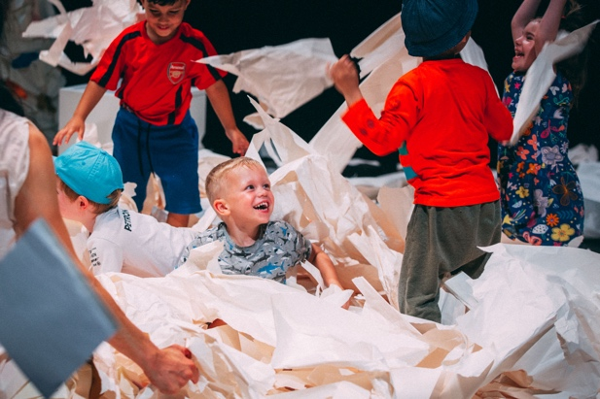 | - Now you can stay and play with the paper.  - You can ask grownups to take photos too.  - Make sure grownups stay close to you so that you don’t get lost in the paper mess.

