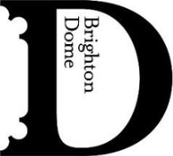

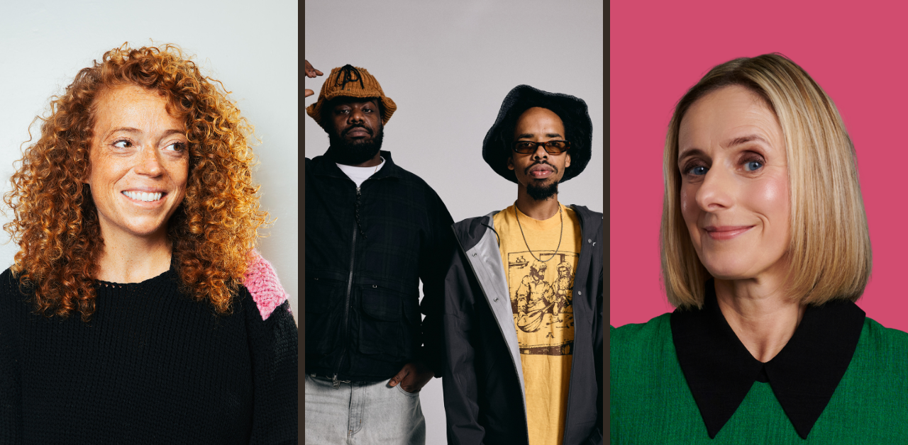

What’s On This Summer at Brighton Dome

Brighton Dome welcomes a host of cultural highlights this summer, including international comedians, world-renowned musicians and celebrated authors and podcasters.

Primetime Emmy-nominated comic Michelle Wolf brings her trademark wit and sharp social commentary in her new show Best Job in the World (11 Jul, Brighton Dome Corn Exchange). Multi-award-winning South African-New Zealander Urzila Carlson returns to the UK with Fatty on a Yacht: a show about not fitting in, standing out, and laughing about it anyway (19 Sep, Brighton Dome Concert Hall). Following two sold-out tours, Vittorio Angelone brings his hit show You Can’t Say Nothing Anymore to Brighton Dome Corn Exchange (19 Sep). And Jonathan Pie, “the UK’s angriest news reporter”, presents his guide to surviving a political apocalypse (23–24 Sep, Brighton Dome Concert Hall).

Brighton Dome’s Concert Hall hosts the best of contemporary and classical music this September. Rapper and record producer Earl Sweatshirt teams up with premier NYC underground hip hop artist MIKE, playing from their critically-acclaimed joint record Home on the Range (3 Sep). Songwriter and multi-instrumentalist Freya Ridings performs from her new album The Pearl (17 Sep). Influential indie dance and electronic pop trio Saint Etienne perform as part of their farewell tour on 25 Sep, followed by an after party in Brighton Dome’s Studio Theatre DJ’d by the band and special guests: a one-off experience unique to Brighton. And on 27 Sep, Brighton Philharmonic Orchestra open their Autumn season with Rhapsody on the Theme of Paganini, performed by two young virtuoso musicians and conducted by BPO Musical Director Joanna McGregor.

In Brighton Dome Corn Exchange: celebrated author and technology critic Cory Doctorow (Enshittification) is joined in conversation by award-winning journalist Carole Cadwalladr as they discuss his latest book, The Reverse Centaur’s Guide to Life After AI (8 Sep). And The Times columnist and bestselling author Caitlin Moran reveals How to be Hopeful: a book on releasing anxiety and rediscovering love of the world through small, everyday actions (13 Sep). In Brighton Dome Concert Hall: political commentator and former Trump White House Director of Communications Anthony Scaramucci discusses his new book All the Wrong Moves on 15 Sep – the eve of the US midterm elections – exploring power, populism, media and the future of democracy in the United States and beyond. And Sunday Times bestselling author and co-host of hit podcast ‘The Rest is Entertainment’ Marina Hyde dissects our stranger-than-fiction times in conversation with critically-acclaimed screenwriter Jesse Armstrong (26 Sep).

Comedy at Brighton Dome is supported by Mayo Wynne Baxter.

For more details visit brightondome.org

ENDS

Notes to Editors
For more information or to arrange interviews, previews and reviews, please contact:

Katie Fowler, Communications Manager – katie.fowler@brightondome.org
Alex Jacobs, Communications Officer – alex.jacobs@brightondome.org

Images: https://tinyurl.com/BDsummer2026

About Brighton Dome & Brighton Festival
Brighton Dome & Brighton Festival is a creative charity that produces a year-round programme of music, comedy, theatre, dance, literature, conferences and events across three venues - the Concert Hall, Corn Exchange and Studio Theatre. We produce Brighton Festival, England’s largest multi-arts international Festival, over three weeks every May and are the home for Create Music, which provides music tuition and opportunities to over 30,000 children in over 500 schools across the whole of Sussex.

Located on the Royal Pavilion Estate, Brighton Dome’s venues have a rich history spanning over 200 years, providing extraordinary spaces for artists and audiences. A major capital refurbishment project to restore and protect the Grade I and Grade II listed Corn Exchange and Studio Theatre was completed in 2023, equipping these spaces for a sustainable future.

brightondome.org / brightonfestival.org / createmusic.org.uk
TikTok: @brightondome and @brightonfestival
Instagram: @brighton_dome, @brightonfestival, @createmusicuk, @futurecreatorsuk
Facebook: brightondome, Brighton Festival, createmusic, futurecreatorsuk
Twitter: @brightdome, @brightfest, @createmusicUK, @FCreatorsUK

