Brighton Dome & Brighton Festival
Venue Access Information
Brighton Dome Corn Exchange

Welcome

Welcome to Brighton Dome, the south coast's premier multi-arts venue at the cultural heart of one of England's most creative cities.
Each year, we present and produce over 600 events spanning music, theatre, dance, comedy, literature, spoken word, visual arts, film, digital and more. In addition to the year-round programme, each May we produce England's leading and most-progressive mixed-arts celebration, the internationally acclaimed Brighton Festival.
With a rich history spanning over 200 years (starting life as the Prince Regent's stables and riding house), Brighton Dome provides an extraordinary space in which to bring the arts alive.
A hub for artists across the region, Brighton Dome commissions and supports both emerging and established artists and companies, enabling them to develop, take risks and deliver work of the highest quality. Read about our Associate Artists and programming partners.
We're committed to making a visit to Brighton Dome easy and enjoyable for as many people as possible.
We regularly programme music, theatre and dance performances for adults and young people with a range of access needs in mind - including BSL interpretation, relaxed performances, touch tours, productions by disabled artists, and a partnership with a Brighton learning disability arts charity Carousel.
A list of assisted performances can be found here.
Brighton Dome is supported by Brighton & Hove City Council and Arts Council England.
Brighton Dome comprises three performance venues:
The Concert Hall , Corn Exchange, and Studio Theatre

Brighton Dome Corn Exchange offers:
- Accessible toilets
- Accessible lifts including evacuation in the Corn Exchange and Studio Theatre where location of fire permits
- Ticket office with low level counters
- Ticket office – induction loop
- Venue bar with low level counter
- Mobile connect assisted listening system
- Staff trained in accessibility awareness
- Free ticket for a Personal Assistant (subject to availability)
- Dedicated Access Line for telephone enquiries about access
- Dedicated access inbox for enquiries
- Specific performances captioned, BSL interpreted, and audio described
- Specific ‘chilled’ performances
- Quiet spaces available wherever possible and always if booked in advance

For information about Brighton Dome Studio Theatre click here Studio Theatre
Or visit http://brightondome.org/access/
For information about Brighton Dome Concert Hall look here http://brightondome.org/access/
This document covers information about Brighton Dome Corn Exchange.
We are committed to making our venues easy and enjoyable places for all to visit. We aim to do more than the minimum required by the Equalities Act 2010 and work positively to improve the experience of our disabled visitors.
Our Ticket Office Staff will be able to assist you with booking tickets for our performances if you need a PA ticket or wheelchair position.
Contact: 01273 709 709 / tickets@brightondome.org
All other tickets can be booked online at https://brightondome.org/whats-on/
Our Visitor Services Team are here to ensure that your visit is easy and enjoyable and to discuss any complex requirements that you may have. For advice and information from the team
Please telephone 01273 261 541
Or email access@brightondome.org

Welcome Area ticket office
Our Ticket Office provides:
- Level, step free entry
- A push-pad automatic door, button location to the right of the door, low level (coming soon)
- Low level counter
- Induction loops
- Staff trained in disability awareness
- Information in large type by request
- A magnifying glass
- Pen and paper are available on request
- The floor is level throughout
- Background music maybe playing
- Chairs available

New Road Ticket Office Entrance

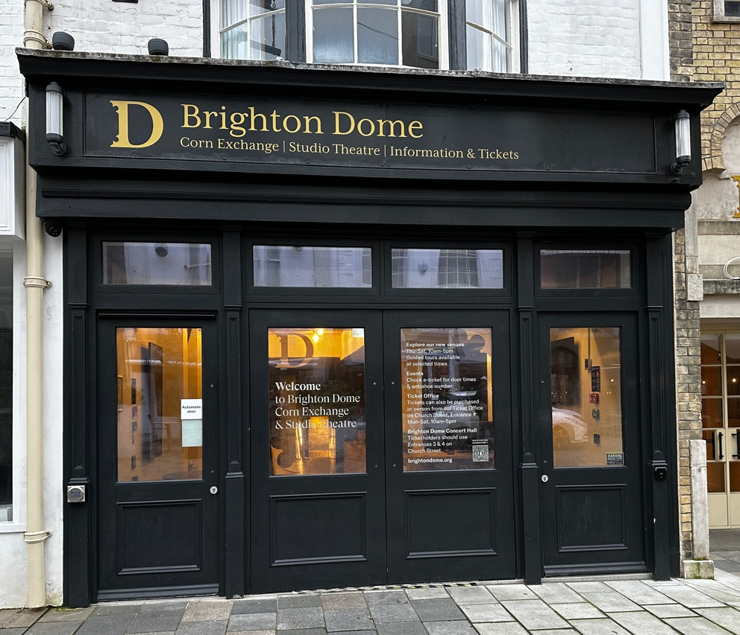

New Road Entrance Accessible Door – 79cm width, push button on the left
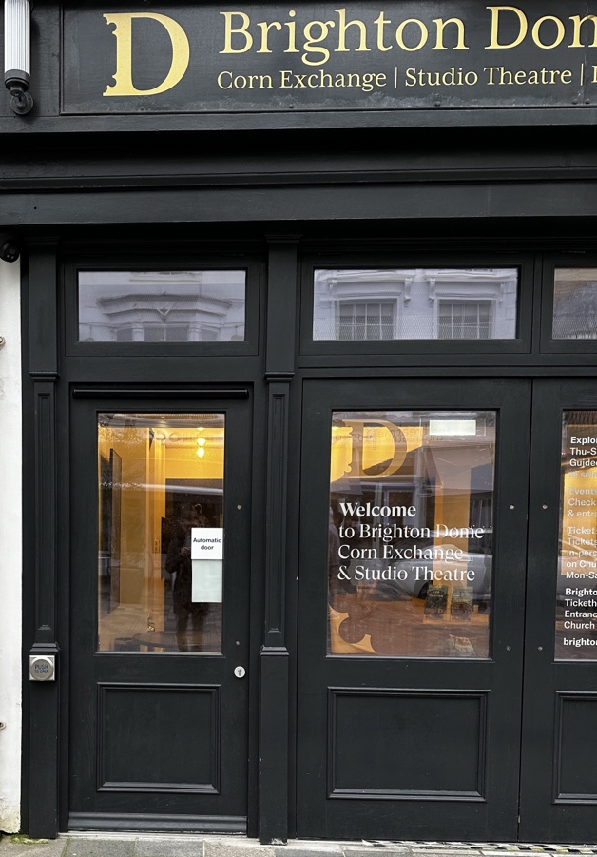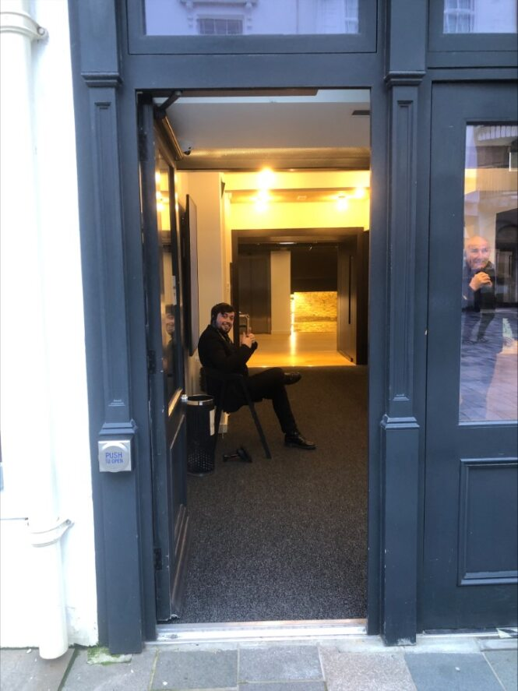

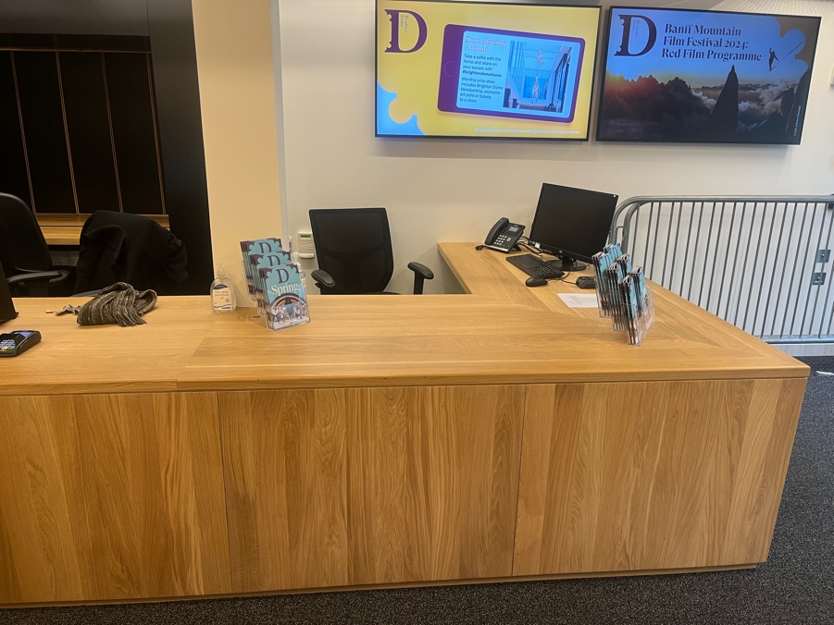
Lowered counter

Tickets and Access Assistants
- Concessionary priced tickets, where available, are offered to people with disabilities.
- In order to apply for the free personal assistant ticket we ask people to sign up to our access scheme by filling out a short form and providing some evidence. The information on this and link to the form can be found here - https://brightondome.org/access/ If you require any help filling out the form please get in touch via our email address access@brightondome.org.
- Additionally, any customer with disabilities who would otherwise not be able to attend the performances without help may apply for one free ticket to bring an Access Assistant with them to the venue to make their visit possible. If you need
- This offer is open to all people who would otherwise not be able to enjoy events here at Brighton Dome, not just those with mobility issues. If you need to book these tickets, please contact the Ticket Office on 01273 709709.
- Access Assistants should be able to sit in a seat next to or very nearby the customer with access requirements.
- Please note that free tickets are subject to availability so please book early to avoid disappointment.
- We encourage our customers to discuss any particular needs with Ticket Office staff when making their booking in order that their specific requirements may be established.
- Anyone with complex needs should speak with the Visitor Services Department at the time of booking who will be able to offer additional advice plus arrange for assistance from staff on the day of your visit. The easiest way to contact the Visitor Services team is through email on access@brightondome.org
- If you would like to visit the venue before the event you are attending the Visitor Services team will happily arrange this for you too.
Wheelchair users and those with Mobility Issues
Brighton Dome Corn Exchange is fully accessible to people with mobility difficulties and wheelchair users. The entrances to the venue are step free and lifts where required can be used to access all public areas. Low level service counters are provided on all Bars and at the venue-based Ticket Office areas in Brighton Dome.
The entrance to Brighton Dome Corn Exchange’s Ticket Office on 29 New Road is also step free with an automatic door and there is a low level counter where wheelchair users may get access.
Access Lifts
We have lifts to access every floor in Brighton Dome Corn Exchange, pictures and measurements of these can be found below.
Platform Lift:
Used only for access from Church Street Entrance into Festival Bar (alternative routes are available)
Door Width approx 80cm
Length approx 146cm
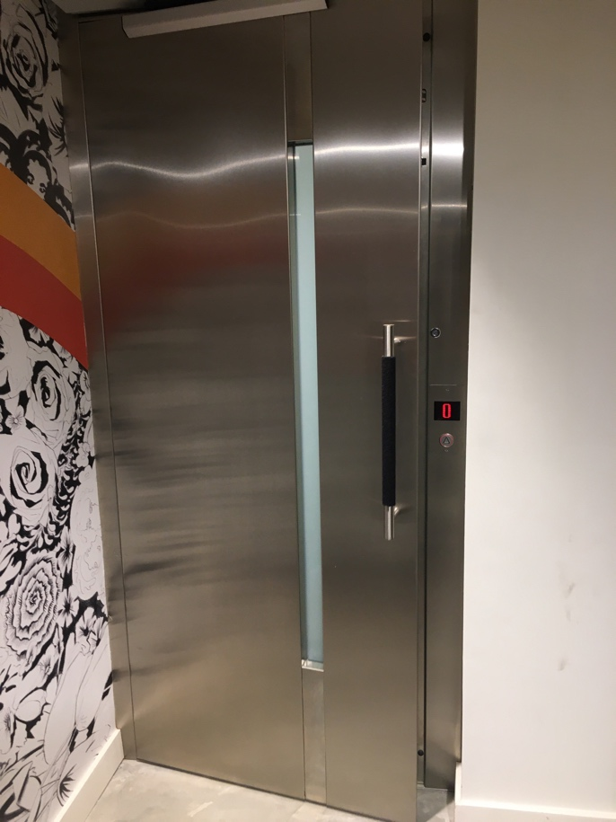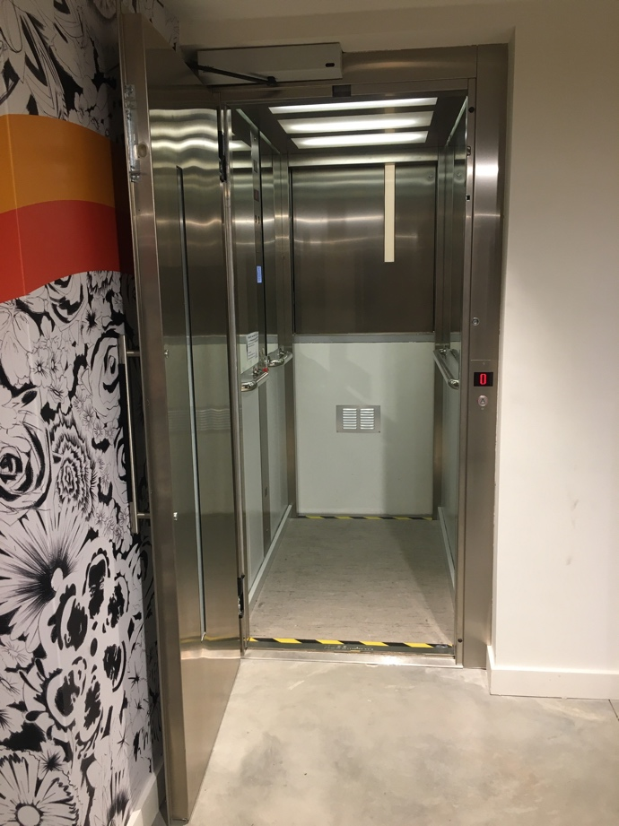

Front of House Lift:
Door Width approx 90cm
Length approx 185cm
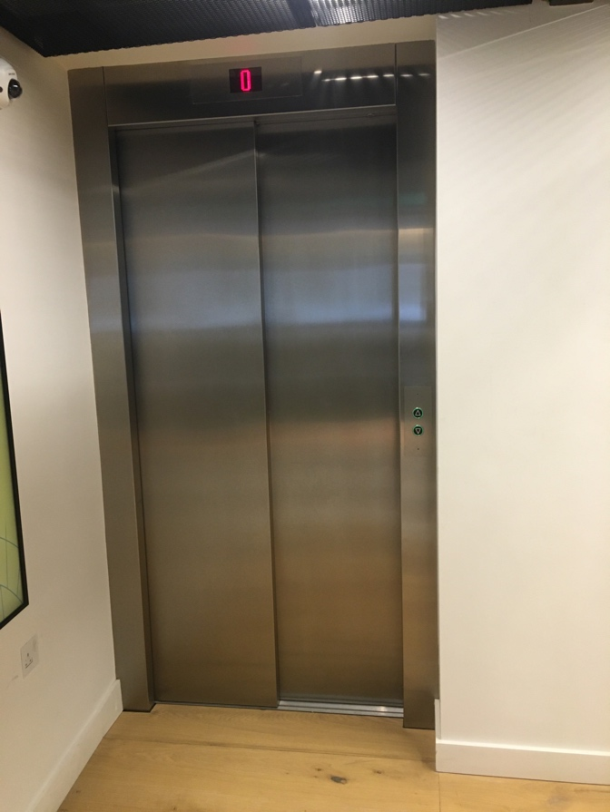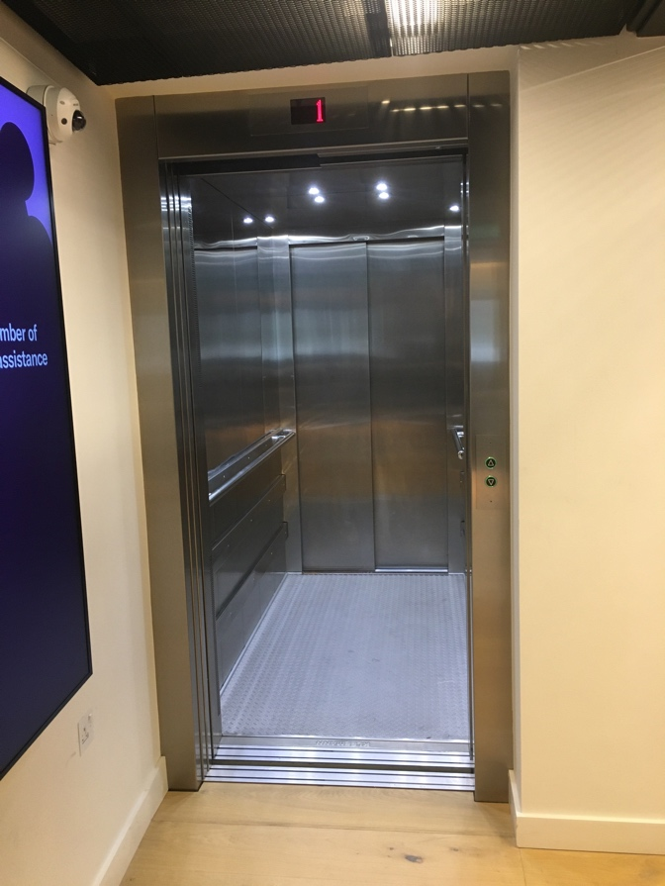

Accessible Toilets
We have accessible toilets on both Bar levels in Brighton Dome Corn Exchange. Pictures and measurements of these can be found at the bottom of this document. In order to ensure that accessible toilets are prioritised for disabled customers, most require a RADAR key to gain access. RADAR keys can be requested from FoH staff located nearby.

Festival Bar
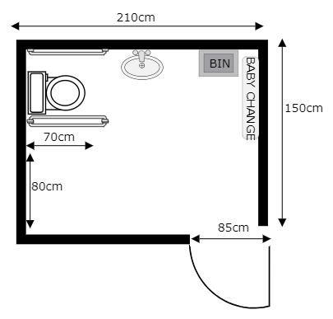

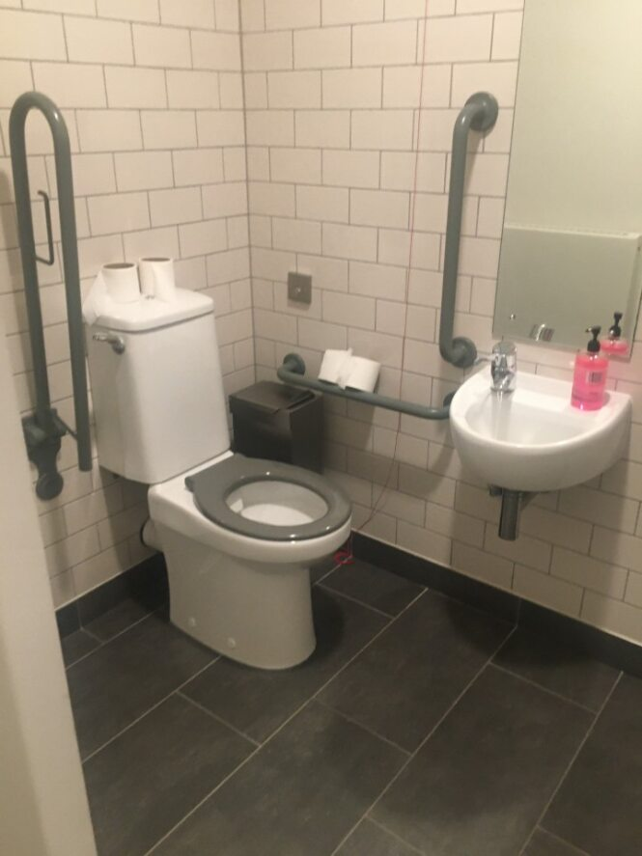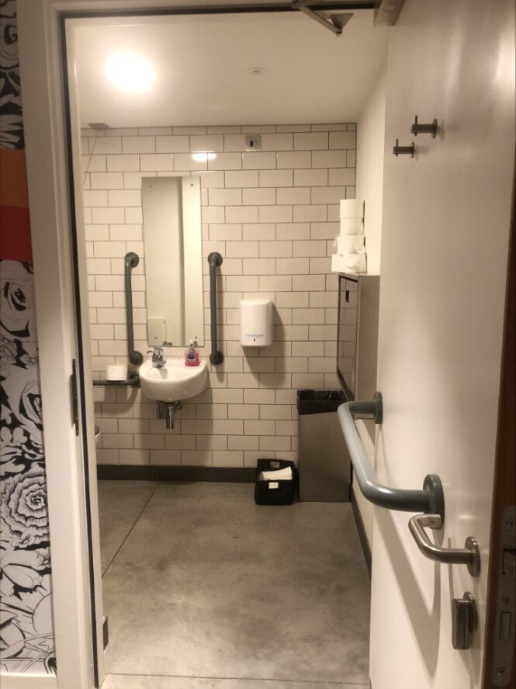

Gallery Bar
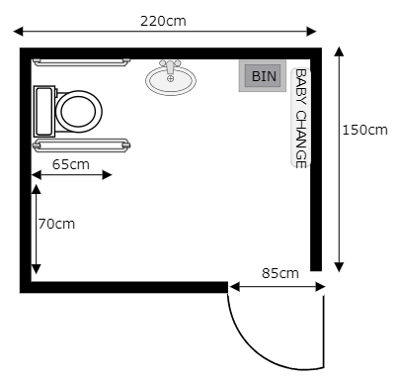
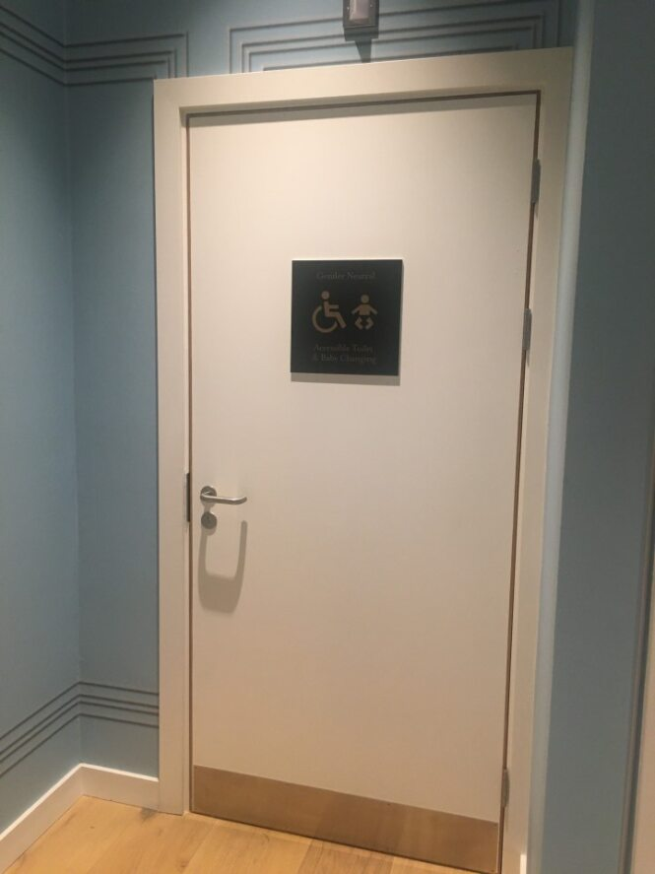

Wheelchair users attending seated events
As Brighton Dome Corn Exchange has a variety of seating layouts, please discuss your requirements with our Ticket Office Assistants when booking. Our wheelchair positions for all Corn Exchange seated shows are in the front row of the raised bleachers. There is a seat next to each wheelchair spot for a PA if needed, two seats are held per 1 wheelchair in addition to the PA seat. We can usually accommodate the whole party in the same area.
Please note that when booking you should notify the Ticket Office staff if your wheelchair is any larger than a standard seat as we may need to make special arrangements to accommodate you in our smaller venues. If you have the measurements, this is very useful.
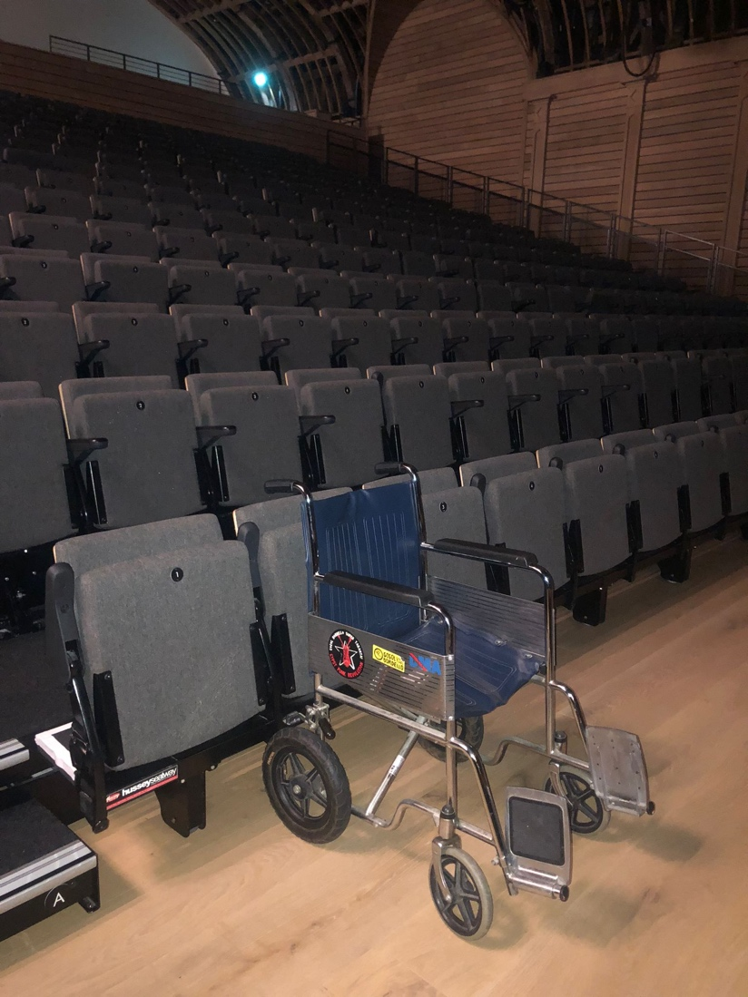

Transfers
Those customers who use a wheelchair but who prefer to sit in a standard theatre seat may choose to ‘transfer’ and store their wheelchair with staff in an agreed place. In the interest of the safety of the person transferring, and the audience, unless customers can walk well enough without assistance to evacuate themselves from the venue in the event of an evacuation the stewards and access assistant would bring the wheelchair to the seat following the main flow of the evacuation and help the customer to safety.

Wheelchair Users attending standing events
Brighton Dome Corn Exchange has a designated viewing platform for most standing shows that can accomodate 6 wheelchair users and their PA’s. There is also limited additional space on the platform for freestanding chairs. No one is permitted to stand on the viewing platform. It may not be possible to accommodate the entire party on the platform, but we will always reserve seats close by if requested. Wheelchair users can move around the space as they wish to.
Putting Seats out at standing events
For the majority of standing events, it is not safe or practical to allow seats in the standing areas. Exceptions may be made at certain events and under certain circumstances. Each event would be assessed for suitability and every effort made to assist disabled customers. Please contact the Visitor Services Team to arrange this.
Borrowing Brighton Dome Wheelchairs
Brighton Dome has two wheelchairs which are available to customers for short term loan during events. Specific requests should be directed to the Visitor Services Team.
Temporary Disabilities
For those people who may have a temporary disability (such as a broken leg) we will endeavour to find seating which is most comfortable for you. Please speak to the Ticket Office. Please note that free access assistance tickets are not available to those with temporary conditions such as these.
Deaf and Hard of Hearing Customers
The Corn Exchange and Studio Theatre has been set up a Wi-Fi based system, Mobile Connect, which operates through your smartphone or tablet. We recommend downloading the free app ahead of your arrival to ensure a smooth and simple process. Please see details below of how to connect your personal device. You can either use headphones or connect them to your digital hearing aids and listen to the performance from anywhere in the auditorium. If you are unable to use the app or require the venue to provide wired headphones, please arrive with plenty of time so that we can provide you with one of our devices and help you get set up.
Using your smartphone:
Download the free app Mobile Connect on the App Store for Apple or Google Play for Android.
Connect to Brighton Dome Wi-Fi.
Connect your wired headphones (note - Bluetooth headphones will operate with a short delay, wired headphones are available on request).
Scan the QR code provided by our staff.
Select show relay to hear the enhanced audio or select audio description if you are attended a specific performance that is being audio described.
Adjust the volume to a comfortable level.
Turn your phone to silent and enjoy the show.

Visually impaired customers
Access dogs are welcome in all Brighton Dome venues, please let us know if you are bringing your dog along so we can find a seat that’s comfortable for you and your dog.
Printed materials can be viewed at the ticket office and are also available to download from our website here https://brightondome.org/access/
Our signage is designed to maximize visibility.
Should you wish to have the venue or directions to the venue described, please contact our Visitor Services Team who will be happy to provide you with information.

Haze, Strobe and Flashing lights
Strobe lighting, lighting that produces stroboscopic effects, smoke machines and other theatrical effects may be used during shows in our venues. If you have concerns about any of these elements being in a performance that you are coming to see, please contact Visitor Services on access@brightondome.org who will do their best to confirm what effects will be in use. Please note that this may not be instantaneous as we may need to contact the promoter to get more information.
There will always be signage up in the venue when haze or strobe is in use and when sound levels go over 82DCB.

Access dogs
We welcome all assistance dogs as they have high levels of training and are used to a variety of different environments. These can either stay with you or we can arrange to look after your dog outside of the auditorium. Please contact access@brightondome.org if you wish to make this arrangement. The Ticket Office will be able to advise on the best seats for you and your dog. Unfortunately, we cannot accommodate emotional support animals as they do not have the same level of training, and our venues can be a busy and intense environment for untrained animals.
Involuntary Noise
Customers who make involuntary noise, or use noise to communicate rather than words, are welcome to attend performances in all venues at Brighton Dome.
We are committed to ensuring that visits are enjoyable and easy – please speak to our Ticket Office staff when booking to discuss your requirements and the seating available. Our managers need to balance the enjoyment of the audience as a whole and therefore if disturbance is judged to be unreasonable for the nature of the event and prolonged, it be may necessary to ask you to take a break from the auditorium or in extreme circumstances for customers to be asked to remain outside the auditorium for the rest of the show. We aim as much as possible to avoid this.
TVs are available in spaces outside the auditorium in order to watch the performance and we are happy to help find a quiet space if someone needs to reset.
We have worked with Carousel, an organisation which supports access to the arts for learning disabled people, to increase the accessibility of our venues to customers with learning disabilities. We also welcome input from Access Assistants bringing individuals or groups to the venues. Please feel free to give us a call to discuss your visit.

Sounds and smells
Some of the sounds you might hear in the Corn Exchange Foyer
- Coffee machine
- Background music
- Sound bleed from the auditorium
- Announcements to indicate the start time of the show and the interval ending
- Customer interactions
- Last orders bell
- Staff radios
- Glass being disposed off behind the bar
Smells you may come across in the Corn Exchange Foyer
- Coffee
- Beer
- Wine
- Cleaning products
- Cakes and pastries
Free hearing protection is always available at the venue, please ask a member of staff or help yourself from the tables by the auditorium doors.

Auditorium Chair widths
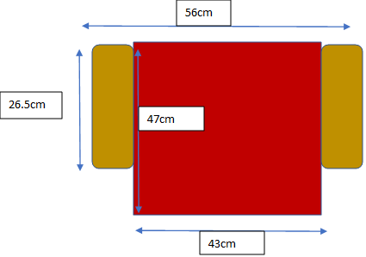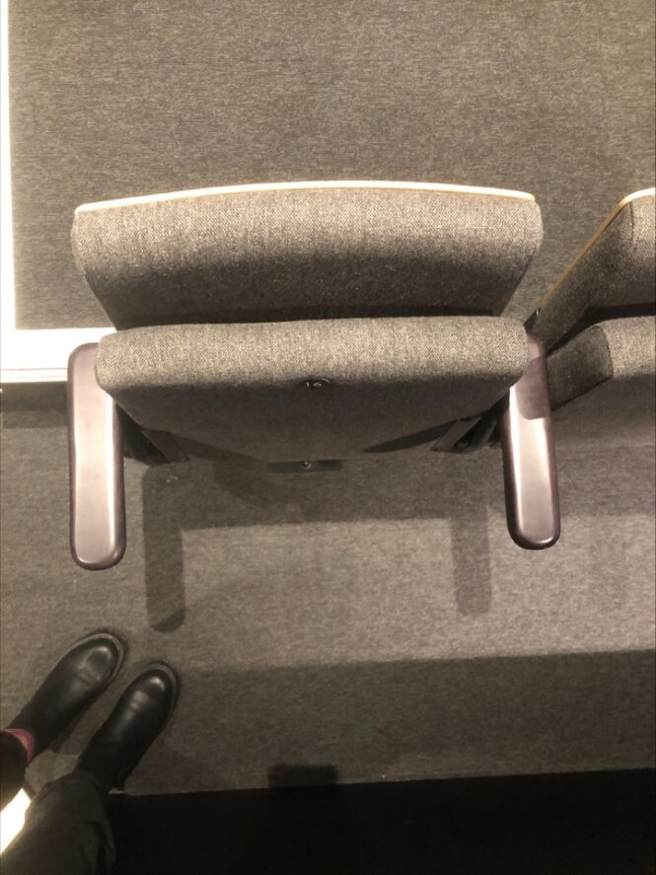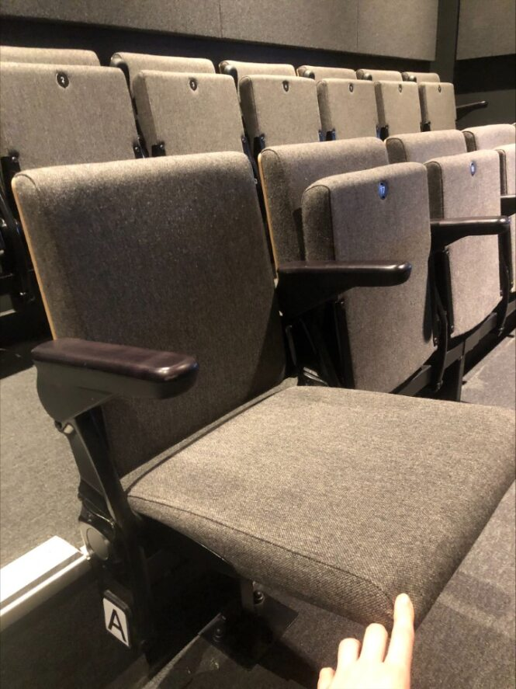
Getting Here

For full details and maps of how to reach us please see our website http://brightondome.org/your_visit/getting_here/

For full details on blue badge parking facilities nearby please see our separate statement on this here - Blue Badge Parking Guidance
Shopmobility
Brighton & Hove Shopmobility is a scheme that provides wheelchairs, electric mobility scooters and powered wheelchairs to members of the public with mobility issues. The scheme is run by Possibility People and enables people the freedom to travel anywhere within the Brighton & Hove area.

Web: https://www.possabilitypeople.org.uk/our-services/shopmobility
Email: hello@possabilitypeople.org.uk
Tel: 01273 89 40 40
Open hours - Monday to Friday, 9am – 5pm. Times may vary during autumn/winter months.

Emergencies
Personal Evacuation Plans
If any disabled customer wishes to discuss a Personal Evacuation Plan with the venue Manager before the visit, we would be very happy to help. Please contact the Visitor Services Department in order that we may relay information to staff on duty that day.
Where there are second floor areas in use, we have evacuation lifts that can be used by trained staff in the event of an emergency. Should the lifts fail for any reason, we also have evacuation chairs and staff trained to use them.
Personal Needs
Please note that our staff are not trained to lift or carry people who may need help or to assist with other personal toilet or medical needs. We provide a free access assistant ticket in order that customers with these needs may be able to attend. If you require a quiet space in which to spend some time during your visit, please speak to our front of house staff who will put you in contact with a manager.
Medical Assistance
There are trained first aiders available at all our events and for large scale events Epione Medical are present. The hospital is 6 minutes away, Royal Sussex County Hospital, Eastern Road, Brighton, East Sussex, BN2 5BE. We have a 1st Aid room which can also be used as a quiet space.
Feedback
We are always looking for ways to improve the service we provide our customers. All projects we undertake are assessed for accessibility compliance, so please contact us if you have any comments or suggestions about this access statement or anything else that could improve your visit to us. Please email access@brightondome.org with your feedback or suggestions.

Stairs in Corn Exchange

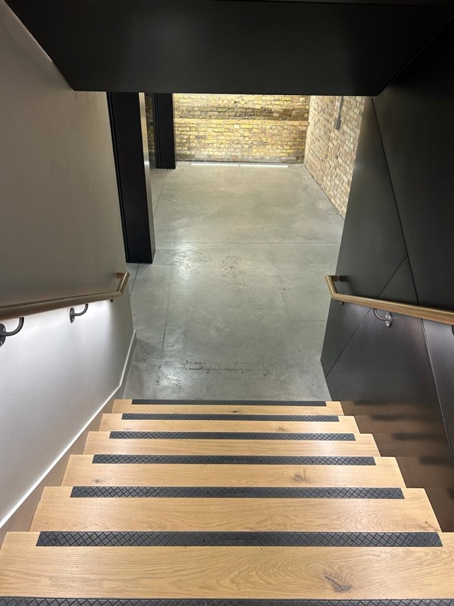
Welcome Area to Festival Bar – 1 flight, 7 steps
Material – wooden
Hand rails either side

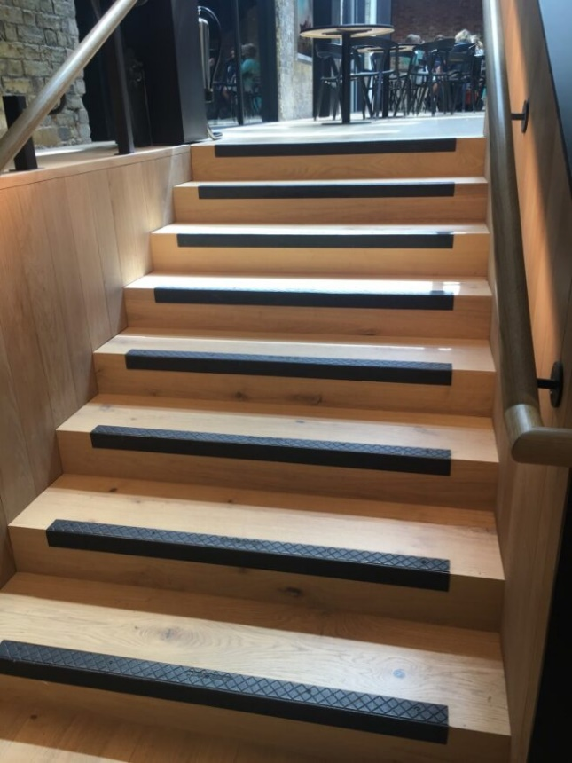

Festival Bar to Gallery Bar flight two – 8 steps
Material - Wooden

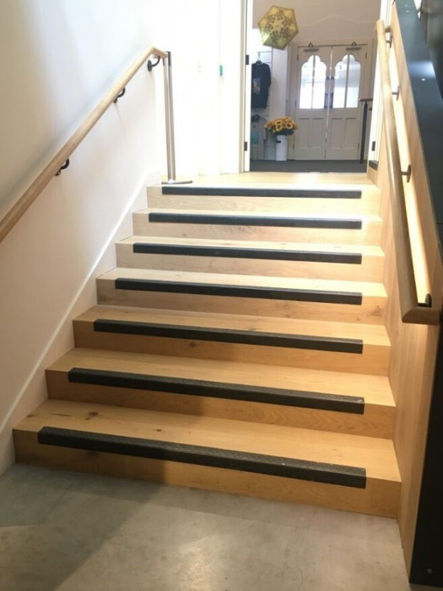

Festival Bar to Gallery Bar flight one – 7 steps
Material – Wooden

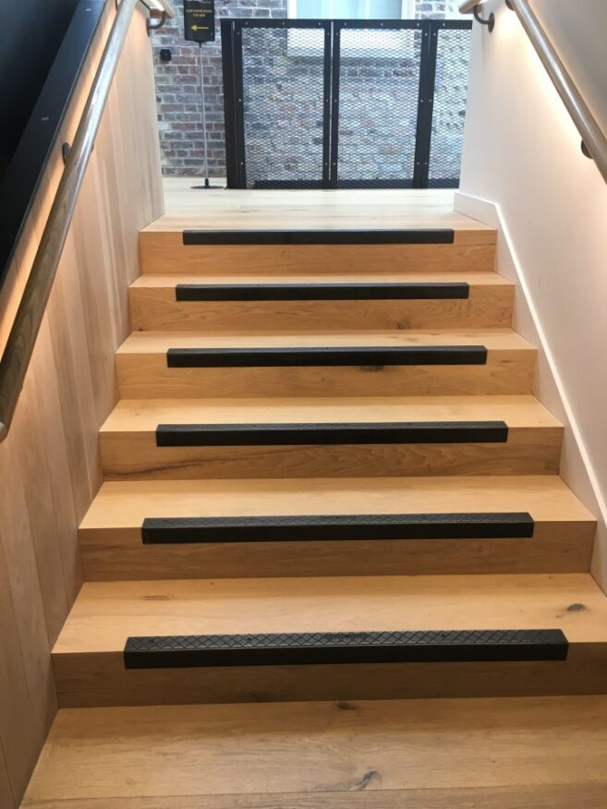

Gallery Bar to Studio Theatre – flight 1 – 9 steps, flight 2 – 6 steps
Material – wooden

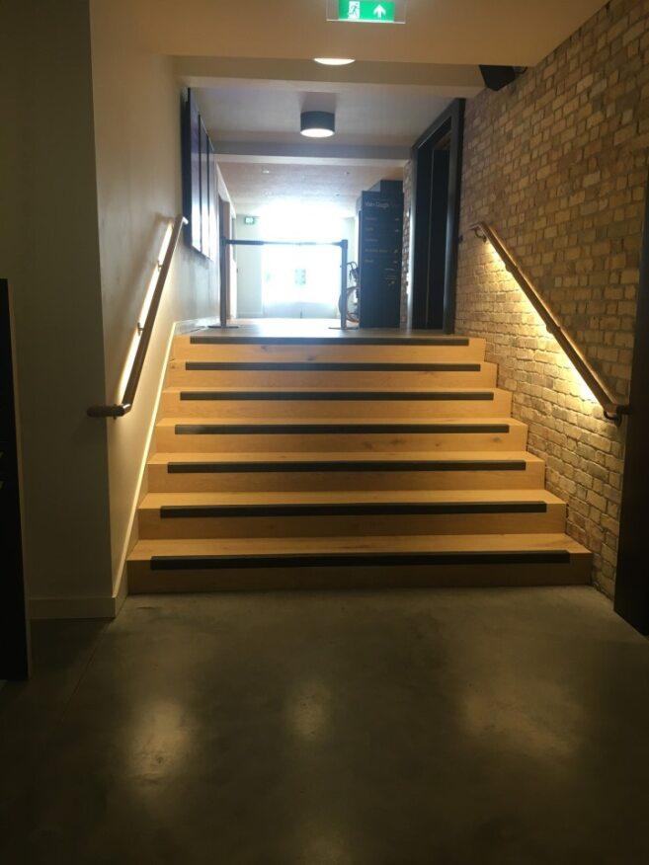

Corn Exchange lower lobby to upper lobby
7 steps

