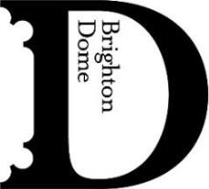
5 FEBRUARY 2026 – FOR IMMEDIATE RELEASE
A Season of Queer Joy: LGBTQ+ Theatre, Comedy and Drag at Brighton Dome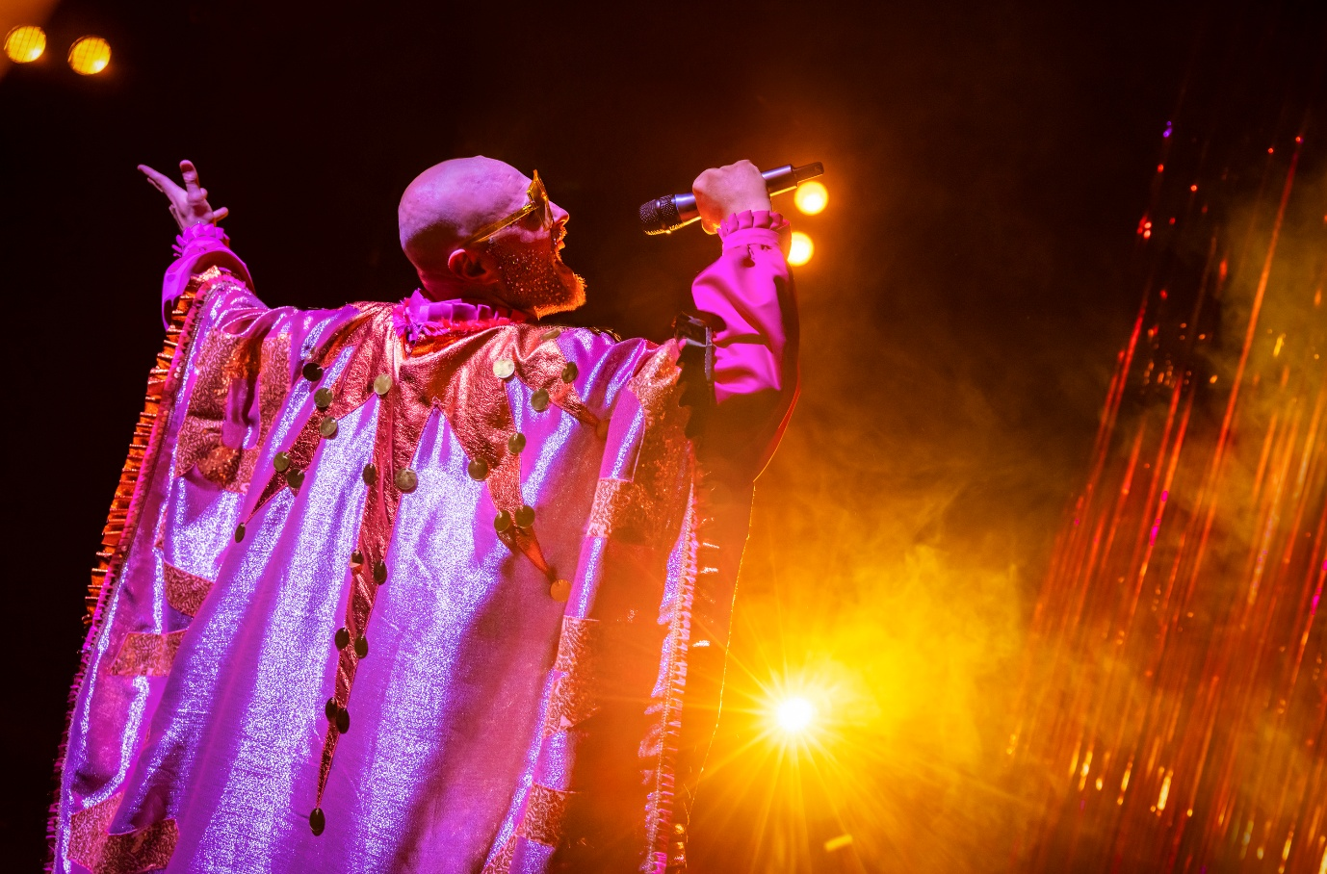

This spring, Brighton Dome welcomes a host of upbeat, camp, and glitter-filled productions for all LGBTQ+ audiences. From tongue-in-cheek drag to cult classic cinema, this season is full of queer joy, humour and authenticity.

From 12–14 February, House of Life transforms the Studio Theatre into a haven of connection and community. Part rave, part theatre, the genre-bending, immersive show is a feel-good evening of music, movement and communal healing. Hosted by the sequin-suited RaveRend, House of Life invites audiences to let go and lean into the freedom of collective celebration.

Renowned drag artist, singer and local legend Ida Barr (Ida Barr Show, Barbican; Ida Barr’s Jubilee, National Theatre) returns to Brighton Dome with Slipped Disco (5–6 March). A retired music hall star turned hip hop artist, Ida Barr galvanises her audience with singalongs, comedy and fresh beats. Quirky, light-hearted and camp, Slipped Disco is a show celebrating the complexity and absurdity of life, in the company of the UK’s premier OAP rapper.

On 17 April, the Concert Hall welcomes The Rocky Horror Picture Show 50th Anniversary Spectacular. Celebrating the 50th anniversary of the LGBTQ+ cult classic, this special screening features a pre-show Q&A with three stars from the original cast, a live shadow cast performance throughout the film, and a memorabilia display featuring original film artifacts. Dress up is encouraged, and prop bags are included with ticket purchase.

Two trailblazing queer female comedians take to the stage at Brighton Dome this season. On 26 February, award-nominated Jessica Fostekew (Travel Man, Channel 4; The Guilty Feminist) brings her hit show Iconic Breath to the Corn Exchange. Witty and hilariously frank, Fostekew delivers sharp observations on being a queer parent and navigating the chaos of modern family life. Fresh from a sellout run in Edinburgh, emerging star Leila Navabi brings her bold one-person show, Relay, to the Studio Theatre (22 May). Blending personal storytelling, original songs and stand-up comedy, Relay explores the trials and joys of queer family-making with humour and warmth.

For more information, visit brightondome.org

ENDS

House of Life
12–14 February
Studio Theatre, Brighton Dome

Jessica Fostekew: Iconic Breath
26 February
Corn Exchange, Brighton Dome

Ida Barr: Slipped Disco
5–6 March
Studio Theatre, Brighton Dome

The Rocky Horror Picture Show 50th Anniversary Spectacular
17 April
Concert Hall, Brighton Dome

Leila Navabi: Relay
22 May
Studio Theatre, Brighton Dome

Notes to Editors

For more information, or to arrange interviews, previews and reviews, please contact:

Katie Fowler, Acting Communications Manager – katie.fowler@brightondome.org
Alex Jacobs, Communications Officer – alex.jacobs@brightondome.org

Images: https://tinyurl.com/BDLGBTQspring26

About Brighton Dome & Brighton Festival
Brighton Dome & Brighton Festival is a creative charity that produces a year-round programme of music, comedy, theatre, dance, literature, conferences and events across three venues - the Concert Hall, Corn Exchange and Studio Theatre. We produce Brighton Festival, England’s largest multi-arts international Festival, over three weeks every May and are the home for Create Music, which provides music tuition and opportunities to over 30,000 children in over 500 schools across the whole of Sussex.

Located on the Royal Pavilion Estate, Brighton Dome’s venues have a rich history spanning over 200 years, providing extraordinary spaces for artists and audiences. A major capital refurbishment project to restore and protect the Grade I and Grade II listed Corn Exchange and Studio Theatre was completed in 2023, equipping these spaces for a sustainable future.

brightondome.org / brightonfestival.org / createmusic.org.uk
Twitter: @brightdome, @brightfest, @createmusicUK, @FCreatorsUK
Instagram: @brighton_dome, @brightonfestival, @createmusicuk, @futurecreatorsuk
Facebook: brightondome, Brighton Festival, createmusic, futurecreatorsuk

